MOTION CLASSES(JELET)
Read instructions carefully

MAXIMUM MARKS: 100 TIME DURATION : 2hrs
1.All questions are compulsory .
2. Darken the appropriate bubbles (abcd) use only black or blue ball point pen.
3. Incorrect answers will carry negative marks, 1/3 marks will be deducted for each wrong answer.
4. Answer with no response wii be awarded zero marks.
5. Multiple marked answers will be considered as negative marks.
6. Calculators and mobile phones not allowed.
7 .Best of luck.

1. which one of the following is wrong?
a) The elements on the main diagonal of a symmetric matrix are all zero
b)The elements on the main diagonal of a skew-symmetric matrix are all zero
c) For any square matrix A,1/2(A+A’) is symmetric
d)For any square matrix A,1/2(A - A’) is skew-symmetric
2 If A and B are symmetric matrices then ABA is
a) Symmetric matrix
b) skew symmetric matrix
c) diagonal matrix
d) scalar matrix
3 If A is skew-symmetric matrix , then trace of A is
a)1 b)-1c)0 d) none of these
4 If A⁻¹ = ,then

a)IAI =2
b) A is singular matrix
c)A is a skew symmetric
d)Adj. A =
5. The sum of the minors of all elements in the second row of determinant is
a) -6 b)5 c)0 d)4
6. If A is a square matrix such that A²=I, then A⁻¹=
a)2A b)A c)0 d)A+I
7. For the matrix equation AB=AC we conclude thatB=C provided that.
a) A is singular b) A is non singular c) A is symmetric d)A is a square
8. If A,B are two n × n non-singular matrices, then
a)AB is non-singular b)AB is singular c)(AB)⁻¹=A⁻¹B⁻¹d)(AB)⁻¹ does not exist
9. If B is non-singular matrix and A is a square matrix, then det(B⁻¹AB) is equal to
a) Det (A⁻¹ b ) Det(B⁻¹) c) Det(A) d) Det(B)
10. If A is square matrix of order n then adj(adj A)=
- IAI^{n-1}A b) IAI^{n-2}A c)IAI^{n-2} d)IAI^{n}A
11. IF B is an idempotent matrix, and A = I - B, then
- A²=A b)AB=0 c)BA=0 d)All of these
12.if A is a skew symmetric matrix of odd order then det(A) is
a)1 b)8 c)0 d)1
13.if A is an orthogonal matrix then det(A) is
a)+_1 b)8 c)0 d)1
14.for any 2*2 matrix , if A(adj A)= ,then IAI=
a) 10 b)100 c)0 d)1000
15.A square matrix is involuntary then (I-A)(I+A) is
a)0
b)-1
c)1
d)all of these
16.A⁻¹ is always
a)symmetric
b)non-singular
c)singular
d)all of these
17.let A=[a_{ij}]_{n*n} where a_{ij}=2i-j is
a)skew symmetric
b)symmetric
c)null matrix
d)unit matrix
18.The vector 2i-j+k,3i-4j-4k and i-3j-5k forms a
a)right angled triangle
b)equilateral
c)isosceles
d)straight line
19.The unit vector along the sum of vectors for 3i+j+5k,2i-j+6k,5i+2j-3k
a)10i+2j+8k/(168)^{1/2}
b)10i-2j+8k/(168)^{1/2}
c)10i+2j-8k/(168)^{1/2}
d) 10i+12j+8k/(168)^{1/2}
20.the vectors 2i-j+k,i-3j-5k,3i-4j-4k are the vertices of the triangle which forms,
a)right angled triangle
b)equilateral
c)isosceles
d)straight line
- Line source of air pollution is developed in
- Single stack
- A road
- A bunch of stacks
- Furnace
- Asphyxiation caused in human body is due to
- Carbon di oxide
- Carbon mono oxide
- Sulpher di oxide
- Nitrogen di oxide
- The atmospheric layer that protects life by filtering out ultraviolet rays is called
- Boron layer
- Ozone layer
- Chlorine layer
- Troposphere
- Thermal Inversion is phenomenon which is associated with
- Water pollution
- Oil pollution
- Air pollution
- Noise pollution
- The area up to 100m radius of health care institute, academic institution and court
- Commercial zone
- Residential zone
- Industrial zone
- Silence zone
- Very fine and light colloidal impurities are removed from water by
- Sterilization
- Disinfection
- Coagulation
- Plain sedimentation
- Fresh water ecosystems can be classified into
- Hot and cold
- Hard and soft
- Flowing and stationary
- Saline and non saline
- The earth day is celebrated on
- 16th September
- 5th June
- 22nd April
- 22nd March

- Population Equivalent is used to determine the loads in the treatment system of
- Noise management
- Waste water management
- Air shed management
- Auto emission management
- Which is the clean fuel to run the car
- Petrol
- Coal bed methane
- Diesel
- Bio-diesel
- Which one is an anaerobic waste water treatment unit
- Trickling filter
- Activated sludge plant
- UASB
- Oxidation ditch
- Which is the world environment day
- 5th January
- 5th June
- 5th March
- 5th November
- Which year GANGA ACTION PLAN is developed
- 1984
- 1985
- 1986
- 1987
- Central pollution protect board is established
- 1981
- 1986
- 1988
- 1983
- Which gas is responsible for the corrosion of the Marble of Taj Mahal
- Carbon di oxide
- Chlorine
- Sulphur di oxide
- Nitrogen di oxide

(36) When a body is subjected to a tensile or compressive force its deformation is:
(i) Δl= Pl/AE,(ii) ) Δl= Pl/2AE (iii) Δl= 2Pl/AE (iv) Pa/lE
(37) A steel bar is heated to tᵒ C and then rigidly bolted at two ends. Stress developed will be of nature--------
(i) Compressive (ii) tensile (iii) bending (iv) shear.
(38) 100 N/mm² is equal to-------
(i) 100 MPa (ii) 150 MPa (iii)50 MPa(iv) none of the above.
(39) Internal resistance offered per unit area by the body on which the force of deformation act is called----------
(i) stress (ii) strain (iii) resistance (iv) friction.
(40)The property of a material by which it can be beaten or rolled in to plates is called
(i) malleability (ii) ductility (iii) plasticity (iv) elasticity.
(41) The phenomenon of slow growth of the strain under a steady tensile stress is called-
(i)yielding (ii) creeping (iii) breaking (iv) none of these.
(42) P = ?
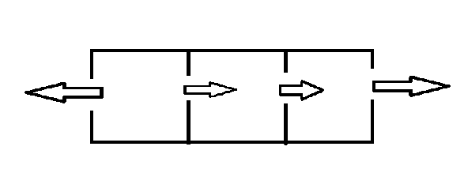
(i) 40 KN (ii) 20 KN (iii) 80 KN (iv) 100 KN.
(43) The unit of moment of inertia
(i) Kg/cm² (ii) KN/mm²(iii) KN. m²(iv) m³.
(44) If polar moment of inertia of a square section is 8Y⁴ unit. Moment of inertia will be ----
(i) 16 Y⁴ (ii) 20 Y⁴ (iii) Y⁴ (iv) 8 Y^{4.}
(45) If dia of circular section is 2m then the MI of the section is
(i) 11/7 (ii)22/7 (iii) (22×16) / 7 (iv) 16/7.
(46) Out of the following which one is non dimensional
(i) Force (ii) work done (iii) stress (iv) strain.
(47) Hooke’s law holds good up to
(i) elastic limit (ii) yield point.(iii) limit of proportionality. (iv) ultimate point.
(48) If a material has identical properties in all direction it is called
(i) Homogeneous.(ii) isotropic(iii) plastic (iv) orthotropic.
(49) The deformation of the body due to load ‘P’=Y KN and self weight ‘W’=Y KN , length ‘L’ area ‘A’ and young’s modulus ‘E’,
(i) 5YE/2AL (ii) 3YE/2AL (iii) 3YL/2AL (iv) 3YL/2AE.
(50) S.I . Unit of young’s modulus …….
(i) N/m².(ii) N (iii) N-m (iv) N-mm².
(51) Angle of repose is the angle between …………
{F= frictional force, N= normal reaction, R= resultant of F & N.}
(i) F & N. (ii) F & R .(iii) F & R (iv) none of the above.
(52) Angle of friction is the angle between……….
(i) F & N. (ii) F & R .(iii) F & R (iv) none of the above.
(53) A ring and a disc have the same mass and radius. The ratio of their MI about their axis is
(i) 1:1 (ii) 2:1 (iii) 4:1 (iv) 1:2
(54) It is the property of a material due to which it resists permanent deformation….
(i) Elasticity (ii) plasticity (iii) ductility (iv) malleability.
(55) It is the property of a material due to which it can undergo permanent deformation……….
(i) Elasticity (ii) plasticity (iii) ductility (iv) malleability
(56) It is the property of a material to be drawn into wires
aElasticity (ii) plasticity (iii) ductility (iv) malleability
(57) ) It is the ability of a material for being flattened into sheets…..
(i) Elasticity (ii) plasticity (iii) ductility (iv) malleability
(58) If a material cannot undergo deformation when some external forces act on it and fails.
(i)Brittleness (ii) hardness (iii) fatigue (iv) creep.
(59) This is the capacity or ability of a material to resist permanent indentation…….
(i)Brittleness (ii) hardness (iii) fatigue (iv) creep.
(60) Where a material will gradually fail after the application of alternating stresses is called…………
(i)Brittleness (ii) hardness (iii) fatigue (iv) creep.
(61)If deformation of a material occurs for a long time such as hours, days, years. Is called…….
(i)Brittleness (ii) hardness (iii) fatigue (iv) creep.
(62) The capacity of a material to withstand or support a external force or load known as……
(i) Strength (ii) toughness (iii) stiffness (iv)resilience.
(63) It is the property on account of which a material is able to withstand bending………
(i) Strength (ii) toughness (iii) stiffness (iv)resilience.
(64) property which capable of resisting deflection………
(i) Strength (ii) toughness (iii) stiffness (iv)resilience.
(65) Property of a material which absorb energy……
(i) Strength (ii) toughness (iii) stiffness (iv)resilience.
(66)The capacity of a material to withstand repeated application of stress….
(i) Endurance (ii) machinablity (iii) workability (iv) weldability.
(67) Property which related t cut to provide it the desired shape and size…..
(i) Endurance (ii) machinablity (iii) workability (iv) weldability.
(68) Property which indicates response for plastic deformation ………
(i) Endurance (ii) machinablity (iii) workability (iv) weldability.
(69) Property indicates respond to the welding process….
(i) Endurance (ii) machinablity (iii) workability (iv) weldability.
(70) The stress which can be safely accepted for the design of the material…
aWorking stress.(ii) ultimate stress. (iii) simple stress (iv) normal stress.
71. Conversion of an octal number 112₈ to hexadecimal number is
(A). 4A₁₆ (B) 5A₁₆ (C) 15₁₆ (D) 20₁₆
72. Address 200H contains the byte 3FH. What is the decimal equivalent of 3FH
(A)63 (B)32(C)16(D)38
73. In which code the successive code characters differ in only one bit position?
(A).gray code (B)excess 3 code(C)8421 code(D)none of these
74. Conversion of binary number 1011012 to hexadecimal is
(A)37 (B)2D(C)2E(D)27
75. What is the 2's complement of 0011 0101 1001 1100 number?
(A) 1100 1010 1100 1011 (B) 1100 1010 0110 0011 (C) 1100 1010 0110 0100 (D) 1100 1010 1111 1111
(D) 1100 1010 1111 1111
76. The hexadecimal digits are 0 to 9 and A to
(A).E(B)F(C)G(D)D
77. The ASCII
(A) is a subset of 8-bit EBCDIC (B) is used only in Western Countries (C) is version II of the ASC Standard (D) None of the above
78. An OR gate has 6 inputs. What is the only input word that produces a 0 output?
(A) 000000 (B) 000111 (C) 111000 (D) 111111
79. The Gray code for decimal 7 is
(A) 0111 (B) 1011 (C) 0100 (D) 0101
80. Conversion of binary number 101000010111₂ to hexadecimal number is
(A)D8F9(B)A8B9(C)A17(D)D9F8

81.Kw/kva in A.C is a)peak factor b)form factor c)power factor d)load factor.
82.Reactive power in A.C is a)VI b)VIcosǾ c)VIsinǾ d)IR
83.In a R-L series ckt supplied with 100 v. the current measured in 100 mA with a phase angle of 60 degree. The reactive power will be a)5 VAR b)10.7 VAR c)8.66 VAR d)none of these.
84.An A.C series ckt is consisting of a resistance of 6 Ω and an inductive reactance of 8Ω is connected to a single phase 200 V,50 HZ supply. The current flowing through the ckt is a)14.3 amp at unity power factor b)10 amp at 0.6 power factor leading c)20 amp at 0.75 power factor lagging d)20 amp at 0.6 power factor lagging.
85.The power factor of a purely inductive ckt is a)0 b)1 c)0.5 d)none of these.
86.Mathematical expression of Ohm’s law
- V$∞$I
- V=RI
- V=RI²
- V=R/I²
87.Kirchhoff’s Voltage law is applied at
- Branch
- Node
- Mesh
- The whole circuit
88.A resistor is that
- Resist the change of flow of current.
- Resist the rate of change of current.
- Flow of current.
- Flow of electron.
89.A node is
- Where one or more than one element are connected.
- Where two or more than two element are connected.
- Where a single element is connected with the source.
- None of these
90. V-I relationship for capacitive element
- i= C$\frac{dv}{dt}$
- i=$\int{C.dt}$
- i= $\frac{1}{C}\frac{v}{t}$
- i= C.V
91. Which one is active element among the following:
- Resistor
- Capacitor
- Transistor
- Operational Amplifier
92.Inductor can create
- Electric Field
- Magnetic Field
- Electrostatic field
- Rotational Magnetic Field
93.Electric current can be defined as
- Rate of flow of proton
- Rate of flow of charge
- Rate of flow of electricity
- Rate of flow of power.
94.Determine node voltage V₁ and V₂
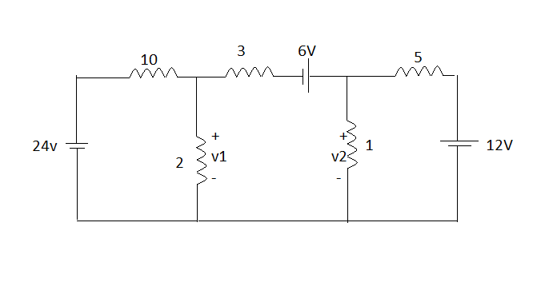
A)V1=1.56 V2 =3.20 B)V1 =2VV2= 4V C)V1= -1.56 V2= -4 D)V1=3.20 V2=1.56
95.What is the power absorbed in the resistors of figure shown below. Assume i₀ = 1 A
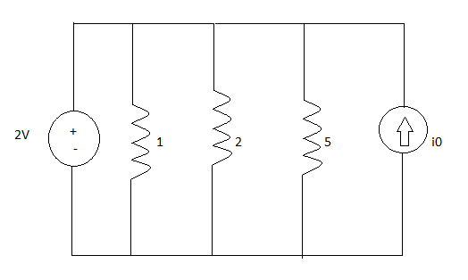
A )P1 4W,P2 2W,P5 0.8W B) P1 - 4W, P2 -2W,P5 -0.8W C) P1 -2W, P2 -4W,P5 0.8W D) P1- 0.8W, P2 2W,P5 4W
96. Addition of 10₂ and 11₂ is
(A) 100₂ (B) 101₂ (C) 111₂ (D) 110₂
97. How many bits are required to encode all twenty six letters ten symbols, and ten numerals?
(A)5 (B)6(C)2(D)3
98. Conversion of decimal number 13₁₀ to its octal number equivalent is
(A) 15₈ (B) 17₈ (C) 13₈ (D) 11₈
99. The binary number 1100 0101 has _____ bytes
(A) 1 (B) 2(C) 4 (D) 8
(100) Factor of safety is defined as the ratio of………
(i) ultimate stress/working stress (ii) ultimate load /working load (iii) both (i)& (ii). (iv) none of the above.

