Know Thyself
"Self-knowledge is the great power by which we comprehend and control our lives."
-- Vernon Howard
Self-discovery is defined as discovering your own individuality. *
Even as children, we dream. We try to realise our dreams all throughout our lives. However, when our dreams remain unfulfilled, we tend to sink into dejection and get disillusioned.
So the question is were our dreams too big for our abilities? Or is it that we never gave it our 100%? In most likely situations the latter answer fits perfectly.
We do not realize our potential and hence fail to meet upon expectations from the society, parents, friends, relatives, peers, superiors, etc.
In his brilliant life research, Psychologist Abraham Maslow decided to explore these highly developed people and he labeled them “self-actualized”. Maslow defines self-actualization to be "the drive for self-fulfillment, namely the tendency for the individual to become actualized in their potential. This is the progressive realization of being everything that one is capable of being."
Drawing on ancient, little-known practices that have been evolved, perfected and refined, Self awareness techniques are more direct and effective for a modern lifestyle. Anyone can apply this work, begin realizing their true power and create amazing results in all areas of their life right away. Many people are already. Why settle for a life of mediocrity or for being partially fulfilled when you can realize your potential, live your dreams and express your greatness!

So let us begin this very interesting Journey of Self Discovery!

SWOT ANALYSIS
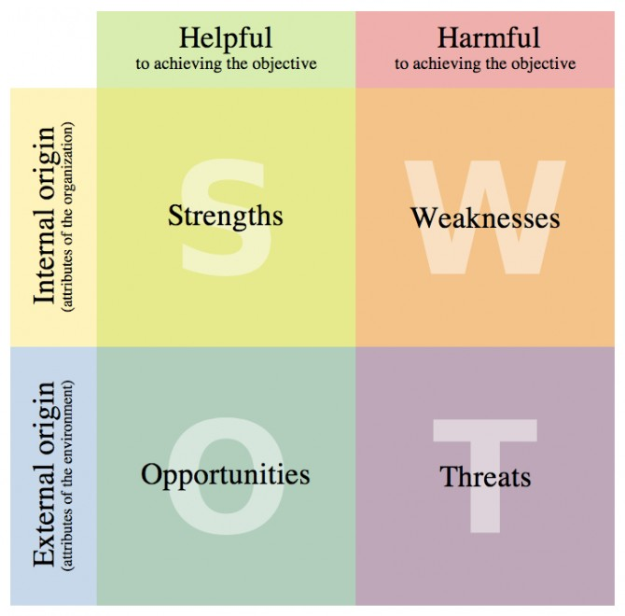
To succeed in your life or for that matter your chosen career, it is important to know yourself personally as well as professionally. You need to be able to critically analyze yourself in order to maximize your potential. A SWOT analysis does this by assessing your personal strengths, weaknesses, opportunities and threats to you in terms of your personal life and in your career.
SWOT an acronym for Strengths Weakness, Opportunities and Threats is and excellent tool for individual as well as organizations. Strengths and Weaknesses are internal to you, Opportunities and Threats are external i.e. Strengths and Weaknesses are your own to control and change while you have no control over opportunities and threats as they are in external environment.

Example of SWOT Analysis:
- Strengths -A person's strengths are areas that give him an advantage in his career. These can include skills, experiences, achievements and education -- among others.
E.g.: Having an advanced degree, leadership experience or a specialized skill.
- Weaknesses-Weaknesses are areas that need improvement. Not having a strength can be a form of a weakness.
E.g.: If someone does not have the skills needed to do a job, it would be a weakness. Weaknesses should be focused on and improved, through training, education and additional experience.
- Opportunities- An opportunity is a favorable circumstance that presents itself to a person. Often, opportunities are the result of strengths.
E.g.: If a person has the ability to speak a second language, it might open up opportunities to work abroad.
- Threats- Threats are circumstances that pose an obstacle to a person's career development. A threat can also be the result of a weakness.
E.g.: If a person lacks the skills to do a job, then she may lose it as a result.
Activity: Make your own SWOT Analysis sheet. And fill your Strengths, Weaknesses, Opportunities and Threats.
List down the points into two sections- Behavioral (e.g.: Practical, Optimist, Short temper, lack of confidence, etc) and Technical (e.g.: knowledge of computers, work experience, project work, etc) and then explain how these can bring opportunities to them or can pose as threats.
This activity can be done in group too. This can be more effective as many a times our friends & family can help in us listing our traits.

JOHARI WINDOW

Johari Window
Johari Window is a model for self-awareness, personal development, group development and understanding relationship. Developed by American psychologists Joseph Luft and Harry Ingham in the 1950's, calling it 'Johari' after combining their first names, Joe and Harry. This model is based on a four-square grid like a window with four 'panes.
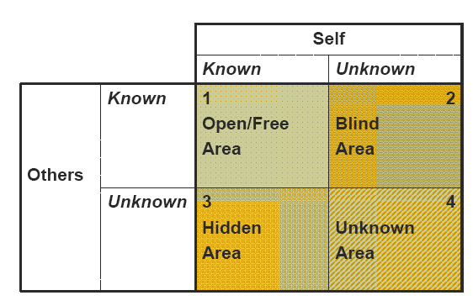
Standard Presentation - Adapted from www.businessballs.com, © Copyright alan chapman 2003
- OPEN /FREE area : Johari region 1 is also known as the 'area of free activity'. This is the information about the person - behaviour, attitude, feelings, emotion, knowledge, experience, skills, views, etc - known by the person ('the self') and known by the group ('others').
The aim in any group should always be to develop the 'open area' for every person, because when we work in this area with others we are at our most effective and productive, and the group is at its most productive too. The open free area, or 'the arena', can be seen as the space where good communications and cooperation occur, free from distractions, mistrust, confusion, conflict and misunderstanding.
- BLIND AREA: Johari region 2 is what is known about a person by others in the group, but is unknown by the person him/herself.
By seeking or soliciting feedback from others, the aim should be to reduce this area and thereby to increase the open area , ie, to increase self-awareness. It is not an effective or productive space for individuals or groups. This tells us about Ignorance about oneself, or issues in which one is deluded. A blind area could also include issues that others are deliberately withholding from a person.
- HIDDEN AREA: Johari region 3 is what is known to us but kept hidden from, and therefore unknown, to others. This hidden or avoided self represents information, feelings, etc, anything that a person knows about him/self, but which is not revealed or is kept hidden from others. This includes sensitivities, fears, hidden agendas, manipulative intentions, and secrets - anything that a person knows but does not reveal, for whatever reason. Relevant hidden information and feelings, etc, should be moved into the open area through the process of 'disclosure'. The aim should be to disclose and expose relevant information and feelings - hence the Johari Window terminology 'self-disclosure' and 'exposure process', thereby increasing the open area.
By telling others how we feel and other information about ourselves we reduce the hidden area, and increase the open area, which enables better understanding, cooperation, trust, team-working effectiveness and productivity.
- UNKNOWN AREA: Johari region 4 contains information, feelings, latent abilities, aptitudes, experiences etc, that are unknown to the person him/herself and unknown to others in the group. These unknown issues take a variety of forms: they can be feelings, behaviours, attitudes, capabilities, aptitudes, which can be quite close to the surface, and which can be positive and useful, or they can be deeper aspects of a person's personality, influencing his/her behaviour to various degrees. Examples of unknown factors are as follows, and the first example is particularly relevant and common, especially in typical organizations and teams. It is an ability that is under-estimated or un-tried through lack of opportunity, encouragement, confidence or training, a natural ability or aptitude that a person doesn't realize they possess, a fear or aversion that a person does not know they have, an unknown illness, repressed or subconscious feelings and conditioned behavior or attitudes from childhood.
Activity: Visit kevan.org/johari and make your own Johari window. You can later share the link of your window with your friends and ask them to fill it up for you. This way you can know more about yourself.

