I - JAVA FUNDAMENTALS

(CHAPTER-1) FUNDAMENTALS OF OBJECT ORIENTED PROGRAMMING

1) Explain the Procedure Oriented Programming and its merits and demerits?

High Level Languages provides an easy approach to the users in developing their logic to solve any problem with the help of a computer. These languages are machine independent because one can develop and understand program logic without having much knowledge about computer’s architecture. High level languages are BASIC, COBOL, FORTRAN and C are commonly known as Procedure Oriented Programming Languages. The Procedure Oriented approach allows the users to develop their logic by applying a number of functions.
A simple flow diagram shows the procedure programming approach :

Main Program
Function - 1
Function - 2
Function - 3
Function - 4
Function - 5

Characteristics of Procedure Oriented Programming:

- Emphasis is on functions rather than data.
- Functions share Global Data
- Uses Top Down approach of programming.

Merits of Procedure Oriented Programming:

- Large programs are divided into smaller programs known as functions.

- Procedure Oriented Programming Structure is easy to follow.

- In Procedure Oriented Programming the problem can be viewed as a sequence of things to be done such as reading, calculating, printing.

Demerits of Procedure Oriented Programming :

- As data value are global to all the functions, If any changes are applied on the global data that changes affect to all functions

- It is not suitable to solve complex problems in real situation.

2) Explain the Object Oriented Programming and its merits and demerits?

Object Oriented Programming (OOP) is an approach to develop the programs by creating partitioned memory area for both data and function. It has been developed to increase the programmer’s productivity and also to overcome the traditional approach of programming.

The main difference of Procedure Oriented and OOP is OOPS does not allows the data to access freely from function to function and procedure to procedure. In this system the complete problem is solved and developed into a number of entities called Objects. These Objects are created and maintained along with a set of related data.
The data are used and maintained in such a way that they can’t be changed or edited from other functions or objects. The data of an Object can be accessed only by the functions associated with that Object. However function of an Object can access the function of the other object.

The different Object Oriented Programming languages are C++, Java, Dotnet languages(C#.NET,VB.NET etc.,), Small Talk, Simula–67 etc.,

Characteristics of Object Oriented Programming:

- It forces the data access only to the corresponding functions of the object.

- It makes the complete program by dividing it into a number of Objects.

Merits of Object Oriented Programming (OOP):

- You can extend the existing class through inheritance.
- Using the concept data hiding can generate secured program.
- It is highly beneficial to solve complex problems.
- It is easy to modify and maintain software complexity.

Demerits or Object Oriented Programming:

- Compiler Overhead
- Runtime Overhead
- Benefits only in long run while managing large software projects

3) Describe ‘Object orientedparadigm ‘andexplain its Features?

Object Oriented paradigm:Object Oriented Paradigm is an approach is to eliminate some of the drawbacks encountered in the procedure oriented approach. In oops data and functions are tied into a single object. It provides security to data and access the data to only that functions of object. The combination of data and methods make up an object. The data of an object can be accessed only by the methods associated with that object. However, methods of one object can access the methods of other objects.
METHOD
METHOD
METHOD
METHOD
DATA

Object = Data + Methods

Features of Object Oriented Paradigm:

1) Data and Methods are bind into single object
2) Programs are divided into objects
3) Data structures are designed such that they characterize the objects
4) Methods that operate on the data of an object are tied together in the data structure
5) Data is hidden and cannot be accessed by external functions.
6) Objects may communicate with each other through methods
7) New data and methods can be easily added whenever necessary
Explain the concepts of Object Oriented Programming?

Object oriented program is a programming approach in which a problem is characterized as a set of objects that have a specific attributes and behavior. The objects are manipulated with a collection of functions called methods or services. The objects are categorized into classes and subclasses.
An object-oriented program can be characterized as data controlling access to code.
OOPS CHARACTERISTICS

1. CLASS 2. OBJECT 3. DATA ABSTRACTION
4. DATA ENCAPSULATION 5. INHERITANCE 6. POLYMORPHISM

1) CLASS: A group of Attributes with its relative behavior kept into a single unit with permitted accessibilities known as a CLASS. A class is a model or blueprint for creating objects.

- A class is a userdefined datatype in oops to define our own datatypes

- class is a blueprint for its objects which supports to create any no. of instances to store specific information

- Class is a logical Entity which allows to keep attributes with its related methods in a single unit with authorized accessing, with security
2) OBJECT: Object is a reference of its class blueprint. This stores a specific data to perform specific operations.

- Object has a physical reality.

- Members of an object are invoked with ‘.’ operator

3) DATAABSTRACTION:

Data hiding means restricting the accessibility of data to outside members, in such a way that it can be used only through the member methods of the object. (OR) Providing essential features without background details or complete implementation i.e., hiding the unwanted data in the program.
4) ENCAPSULATION:

In the class declared variables are called as attributes/Data Members/status and defined functions are called as Member Functions. These both are called as Members. These members are binding into a single unit is called Data Encapsulation.

5) INHERITANCE:

Inheritance is the concept used to share the data of one class into another class. Inheritance is the process by which objects can acquire the properties of objects of other class. This is achieved by deriving a new class from the existing one. The new class will have combined features of both the classes.

There are different types of inheritances are there. They are :

- single Inheritance

- Multiple Inheritance

- Multi-Level Inheritance

- Hierarchical Inheritance

- Hybrid Inheritance

6) POLYMORPHISM:

Polymorphism came from the two greek words ‘poly’ and ‘morphos’. Poly means many and morphos means forms.

The ability to exist in different forms is called polymorphism. An Operation may exhibit different behaviors in different instances. The behavior depends on the datatypes used in the operation.
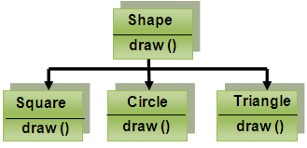

Explain the Benefits of Object Oriented Programming(OOP)?

OOP offers several benefits to the programmer and the user. It promises to programmer in development of productivity, better quality of software and lesser maintenance cost.

The advantages are:

- Through Inheritance, we can eliminate redundant code and extend the use of existing classes.

- We can build programs for standard working modules that communicate with one another.

- The principle of data hiding helps the programmer to build secure programs that cannot be invaded(attacked) by code in other parts of the program.

- It is possible to have multiple instances of an object to co-exist without any interference.

- Object-oriented system can be easily upgraded from small to large systems.

- Message passing techniques for communication between objects makes the interface descriptions with external systems much simpler.

- Software complexity can be easily managed.

6) Explain the Applications of OOPs?

OOPS are used in many areas in software development.

- In Real time systems
- In Object Oriented databases
- In Artificial Intelligence
- In Networks and Parallel programming
- In Office Automation Systems

(CHAPTER-2) JAVA EVOLUTION

HISTORY OF JAVA

The ‘Java’ language was developed by ‘James Gosling’ in ‘June 1991’ for use in a “SET TOP BOX PROJECT”. The language was initially called ‘Oak’, after an Oak tree that stood outside Gosling’s office and also went by the name ‘Green’ and ended up later being renamed to ‘Java’.
- ‘B’ led to ‘C’, ‘C’ evolved into ‘C++’, ‘C++’ set the stage for ‘JAVA’.
- Even though ‘C’ is a general purpose language, its complexity increases once project size reaches certain size.
- To solve this problem, a new way to program was invented, called ‘Object Oriented Programming (OOP)’.
- An OOP method helps us to organize complex programs through Encapsulation, Inheritance, and Polymorphism.
- C++ was developed by ‘Stroustroup’ in 1979.
- Two main drawbacks with this languages are

- It is not suitable for develop Internet applications.
- It is platform dependent language.
In order to solve these problems, ‘James Gosling’ developed a language called ‘Java’ at ‘sun microsystems’ in 1991. Java supports Internet programs, and which is a platform independent language. Java applications are typically compiled to bytecode which can run on any Java Virtual Machine (JVM) regardless of computer architecture.
Explain about the Features of Java? (Refer Notes)(IMP)

How JAVA differs from C , C++ and JAVA(Refer Notes)(IMP)?

Describe Java and Internet?

Java is a Internet language why because Internet users can also setup their websites containing java applets that could be used by other remote users of Internet. Internet users can use Java to create applet programs and run them locally using java-enabled browser such as HotJava.

Explain how the Java is associated with World Wide Web(WWW)?

World Wide Web(WWW) is an open–ended information retrieval system designed to be used in the Internet’s distributed environment. This system contains Web pages. To develop the web pages we use Hypertext Markup Language (HTML). Web pages contain HTML tags. WWW helps us to find, retrieve, manipulate and display documents through world wide.

With the support of Java, the Web has become more interactive and dynamic. On the other hand, with the support of web we can run a Java program on any other computer across the internet.

Java communicates with a web page through a special tag called <APPLET>.

Explain in detail about JAVA ENVIRONMENT?

JAVA Environment:

Java environment includes a large number of development tools and hundreds of classes and methods. The development tools are part of the system known as Java Development Kit (JDK) and the classes and methods are part of the API (Application Programming Interface).

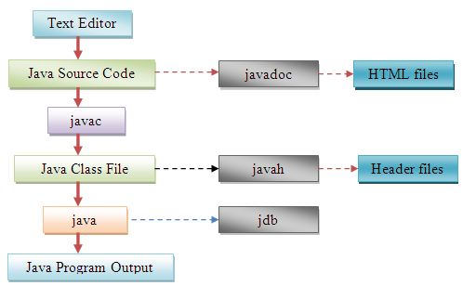

Java Development kit (JDK):

The Java Development Kit comes with a collection of tools that are used for developing and running Java Programs. They include:

- appletviewer (for viewing Java applets)
- javac (Java compiler )
- java (Java interpreter)
- javap (Java disassembler)
- javah (for ‘C’ header files)
- javadoc (for creating HTML documents)
- jdb (Java debugger)

Tool | Description
appletviewer | Enables us to run Java applets (with out using a Java-compatible browser)
Java | Java interpreter, which runs applets and applications by reading and interpreting
Javac | The Java compiler, which translates Java source code to byte code files
javadoc | Creates HTML-format documentation from Java source code files
Javah | Produces header files for use with native methods.
Javap | Java disassembler, which enables us to convert byte code files into a program description
Jdb | Java debugger, which helps us to find errors in our programs.

- To create a java program, we need to create a source code file using a text editor.
- The source code is then compiled using the Java compiler javac and executed using the Java interpreter java.
- The java debugger jdb is used to find errors, if any, in the source code.
- A compiled Java Program can be converted into a source code with the help of java disassembler javap.

(CHAPTER-3) OVERVIEW OF JAVA LANGUAGE

INTRODUCTION:

Explain the Difference between Stand-alone applications and Applets?

Java is a general purpose, object-oriented programming language. Using Java we can develop two types of applications using java programs.
- Stand-alone applications
- Web Applets
Stand-alone applications are the java programs which are existed in local system and are executed in a local computer. Web Applets are the small java programs developed for Internet applications. Web Applets are existed on Web Server and can be downloaded via internet and executed on a local computer using a java capable browser.

Explain simple Java program?

A Simple java program

class Sample
{
public static void main( String []args )
{

System.out.println(“Welcome to Java”);

}
}

Class Declaration:

Class Sample{ } is class declaration, which is an object oriented construct. Java is a true object oriented language and therefore, everything must be placed inside a class. class is a keyword and declares that a new class definition follows. Sample is a java identifier that specifies the name of the class to be defined.

Opening Brace:

Every class definition in Java begins with an opening brace “{“ and ends with a matching closing brace “}”. This is similar to C++ class construct.(Note that a class definition in c++ ends with a semicolon)

The main function:

The main() is defined as the follows:

public static void main(String[] args)
{

//statements
}

Every java program must contain the main() function. This is the starting point for the interpreter to begin the execution of the program. A Java application can have any number of classes but only one them must include a main method to initiate execution. This function contains 3 keywords. They are public, static and void.

public : The keyword public is an access specifier that declares the main method as unprotected and therefore making it accessible to all other classes.

static:The keyword static is a modifier that declares the main method is belongs to that class and not
belongs to specific object. The main must always be declared as static since the interpreter uses this
method before any objects are created.

void : The type modifier void states that the main method does not return any value, it simply prints some text to the screen

main() method takes one parameter String args[] declares a parameter named args, which contains an array of objects of the class type String. It takes arguments through command line when the program is executed in command line.

System.out.println() is a function similar to the printf() statement in ‘c’. The println method is a member of out object, which is a static data member of System class. This statement prints the string at output device.

Explain Java program structure(IMP)?

Structure of a Java Program:

A java program may contain many classes of which only one class defines a main method. Classes contain data members and methods that operate on the data of the class. Methods may contain data type declarations and executable statements. A java program may contain one or more sections as shown below:

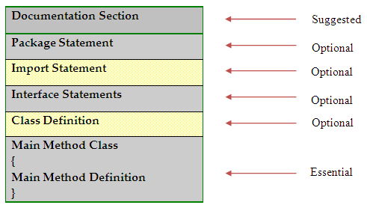

Documentation Section:

The documentation section contains a set of comment lines giving the name of the program, the author and other details. Comments are description about the program. This means that whatever we write in a program should be described using comments.

When we write comments, we can understand what the program is doing as well as it helps others to easily follow our code. This means readability and understandability of a program will be more.

There are three types of comments in java

- Single Line comment
- Multi Line comment
- Documentation comment
Single Line Comment:

These comments are for marking a single line as a comment. These comments start with double slash symbol // and after this, whatever is written till the end of the line is taken as a comment.

Ex: // this is single comment line.

Multi Line Comment:

These comments are used for representing several lines as comments. These comments start with /* and end with */. In between /* and */, whatever is written is treated as a multi line comment.

Ex: /*
line1
line2
line3
*/
Documentation Comment:

These comments start with /** and end with */ these comments are used to provide description for every feature in a java program. Using ‘javadoc’ tool we can generate the documentation file. Java documentation comments should be used before every feature in the program as shown here:

EX: - /**
Description about a class/method/statement
*/

Package Statement:

This statement declares a package name and informs the compiler that the classes defined in the current file belongs to this package. This package statement is optional.
Ex: package student;

Import Statement:

The next statement after a package statement is import statements. This is similar to the #include statement in C, used to import the other package classes in our application.
Ex: import java.io.*;

This statement instructs the interpreter to load the classes in the “io” sub package and it belongs to the main package “java”. Here ‘ * ’ represents the total number of classes and interfaces in the package.

Interface Statement:

An interface is like a class but includes a group of method declarations. This is also optional section and is used only when we wish to implement the multiple inheritance feature in the program. Interface is a new concept in java.

Class Definition:

A Java program may contain multiple class definitions. Classes are the primary and essential elements of a Java program.

Main Method Class:

Since every Java program requires a main method as its starting point, this class is the essential part of a Java program. A simple Java program may contain only this part. The main method creates objects of various classes and establishes communication between them. On reaching the end of main, the program terminates and the control passes back to the operating system.

Explain Java Tokens?

Smallest individual units in a program are known as tokens. A Java program is a collection of tokens, comments and whitespaces. Java language includes five types of tokens.

They are:

- Reserved Keywords
- Identifiers
- Literals
- Operators
- Separators

Reserved Keywords:

Keywords are reserved words which contains specific meaning. Java language has a 61 reserved words as keywords. Since keywords have specific meaning in java, we cannot use them as names for variables, classes and methods. All keywords are to be written in lower case letters.

Abstract | Boolean | Break | Byte | Byvalue | case
Catch | Cast | Char | Class | Const | Continue
Default | Do | Double | Else | Extends | False
Final | Finally | Float | For | Future | Generic
Goto | If | Implements | Import | Inner | Instanceof
Int | Interface | Long | Native | New | Null
Operator | Outer | Package | Private | Protected | Public
Rest | Return | Short | Static | Stritctfp | Super
Switch | Synchronized | This | Threadsafe | Throw | Throws
Transient | True | Try | Var | Void | Volatile
While

Identifiers:
Identifiers are the user defined tokens. They are used for naming classes, methods, variables, objects, labels, packages and interfaces in a program. Java identifiers follow the following rules.
They can have alphabets, digits and the underscore and dollar sign characters.

- They must not begin with a digit

- Uppercase and lowercase letters are distinct

- They can be of any length

Literals: Literals in Java are a sequence of characters that represent constant values to be stored in variables.

They are:
  - Integer literals
  - Floating point literals
  - Character literals
  - String literals
  - Boolean literals

Ex:
int a=5; //5 is integer literal

float b=10.2f; //10.2 is floating point literal

char ch=’a’; //’a’ is character literal

String st=”abc”; //”abc” is string literal

Bool res = true; //true is Boolean literal

Operators:

An operator is a symbol that takes one or more arguments and operates on them to produce a result. Operators are of many types.

Types of Operators

1) Arithmetic Operators: Ex: +, -, *, /, % 2) Relational Operators:Ex: ==, !=, >, <, >=, <=

3) Bitwise Operators: Ex: &, ^, | 4) Shift Operators: Ex: <<, >>, >>>

5) Logical Operators: Ex: &&, ||, !

Separators:Separators are symbols used to indicate where groups of code are divided and arranged.

Ex: () {} [] ; , .

Explain Java Statements?

The statements in Java are like sentences in natural languages. A statement is an executable combination of tokens ending with a semicolon ‘;’ mark. Statements are usually executed in sequence. However, it is possible to control the flow of execution, if necessary, using special statements. Java implements several types of statements.

They are:

- Assignment statements 2) Compound statements3)Conditional statements
4) Switch statements 5) Control statements

- Assignment Statements:
int x = 10;
x = fun();
x = a + b;

2)Compound statements
Are used to define the scope of variables and lifetime of a variable

Ex:
{
int x=10;
}

- Used To define the scope and lifetime of a variable
- Used to execute block of statements at a time
3)Conditional Statements:

If statement
- Simple if
- If else
- Ladder-if(else-if)
- Nested if
4) Switch statement:

switch( expr)
{

case 1: ……………

break;

case 2: ……………

break;

default:
…………
}

5) Control statements:

- While
- do. While
- for loop

Standard for loop

Syntax:
for( initialization; condition; modification )
{
//statements
}

Ex:
int []a={1,2,3,4,5};

for( int i=0; i<5; i++ )
{
System.out.println( a[i] );
}

Usage:
In java we have “dynamic data structures” with auto-growable and auto-shrinkable property. Wherever we don’t want to do initialization, condition and modification we can use Enhanced for loop to navigate the elements otherwise we can go for standard loops.

Explain How to implementing a JAVA program?

Implementation of a Java application program involves a series of steps.

They include

- Creating the program
- Compiling the program
- Running the program

1) Creating the program:

We can create a program using any text editor. Open the notepad and type the following program.

class Test
{
publics static void main( String []args)
{
System.out.println(“welcome to java”);
}
}

After typing the program in notepad we must save this program in a file called Test.java. This file is called source file.

2) Compiling the program:

To compile the program, We must run the Java compiler javac, with the name of the source files on the command line as shown below.

javac Test.java

If any errors are not found in java source file javac compiler creates a file called Test.class containing the bytecodes of the program. The byte code file name extension is .class.

3) Running the program:

We need to use the java interpreter to run a stand-alone program. To run the java program we must pass the class file to java interpreter.

Ex: Java Test

Explain about JVM(JAVA VIRTUAL MACHINE)?

All language compilers translate source code into machinecode for a specific computer. Java compiler also does same thing. Java achieve Architecture neutrality because Java compiler produces an intermedia code known as bytecode.

The bytecode is not machine specific. The machine specific code is generated by the Java interpreter that is JVM.

INTERNAL JVM ARCHITECTURE

class file
EXECUTION ENGINE

RUN TIME DATA AREAS

CLASS LOADER SUBSYSTEM

USERDEFINED BOOTSTRAP
CLASS LOADER CLASS LOADER

METHOD AREA

HEAP AREA

JAVA STACKS

PC REGISTERS

NATIVE METHOD STACKS

INTERPRETER

JIT COMPILER

OPERATING SYSTEM

NATIVE METHOD INTERFACE

NATIVE METHOD LIBRARIES

Java Virtual Machine(JVM) is the heart of entire Java program execution process. It is responsible for taking the .class file and converting each byte code instruction into the machine language instruction that can be executed by the microprocessor.

First of all the .java program is converted into a .class file consisting of byte code instructions by the java compiler. Remember, this java compiler is outside the JVM. Now this .class file is given to the JVM. In JVM, there is a module called Class Loader subsystem, which performs the following functions:

- First of all, it loads the .class files into memory. Class Loader divided into 2 parts one is User defined Class Loader second one BootStrap Loader. User defined Class Loader loads .class files code and Bootstrap Loader loads predefined packages from JAVA API which are defined in the program.

- Then it verifies whether all byte code instructions are proper or not. If it finds any instruction suspicious, the execution rejected immediately.

- If the byte instructions are proper, then it allocates necessary memory to execute the program.
In RAM This memory is divided into 5 parts, called Runtime Data Areas. Which contain the data and results while running the program. These areas are as follows:

- Method Area: Method Area is the memory block, which stores class code(static), code of the variables and code of the methods in the Java program.

- Heap Area:This is the area where objects are created. Whenever JVM loads a class, a method and a heap are immediately created in it.

- Java stacks: Method code is stored in Method Area, But while running a method, it needs some more memory to store the data and results. This memory is allotted on Java Stacks. So, separate frame will be created in Java Stack, where the method is executed. JVM uses a separate thread(or process) to execute each method.

- PC(Program Counter) Registers:

These are the registers(memory areas), which contains memory address of the instructions of the methods. If there are 3 methods, 3 PC Registers will be used to trace the instructions of the methods.

- Native Method Stacks: Java methods are executed on Java stacks. Similarly, native methods(for example c/c++ functions) are executes on Native method stacks. To execute the native methods, generally native method libraries(for example c/c++ header files) are required. These header files are located and connected to JVM by a program, called Native Method Interface.

Execution engine contains interpreter and JIT (Just In Time) Compiler, which are responsible for converting the byte code instructions into machine code. So that the processor will execute them. Most of the JVM implementations use both the interpreter and JIT compiler simultaneously to convert the byte code. This technique is also called adaptive optimizer.

Interpreter executes byte code line by line. If there is any repetitive code that code is taken by JIT and executes at a time. The code which is taken by JIT compiler that code is called hotspots. Thus, both the interpreter and JIT compiler will work simultaneously to translate the byte code into machine code.

Explain Command Line Arguments?

Command Line Arguments:
Through command line arguments we can pass the data to main() of a program. If we pass the values through command Line that will be stored in string []args array in main().

Ex:

class ExOnCommandLineArgs
{
public static void main( String []args )
{
String s1 = args[0];
String s2 = args[1];

int a = Integer.parseInt(s1);
int b = Integer.parseInt(s2);

int c = a + b;

System.out.println(“sum=”+c);
}
}

Explain scope of variables?

Java variables are actually classified into three kinds:

- Instance variables
- Class Variables
- Local variables

Instance and class variables are declared inside a class.

Instance variables are created when the objects are instantiated and therefore they are associated with the objects. They take different value for each object.

Class variables are global to a class and belong to the entire set of objects of that class. Only one memory location is created for each class variables.

Local variables are declared inside methods. They are not available to outside of that method.

These variables are visible to the program only from the beginning of its program block to the end of the program block. When the program control leaves a block, all the variables in the block will cease to exist. The area of the program where the variable is accessible is called its scope.

Explain Symbolic constants?

The variables which are defined using final keyword that variables are called symbolic variables. If we assign the values to symbolic variables that values are called as Symbolic constants. We can’t change symbolic constants once it assigned to symbolic variables. To define the symbolic variables we use ‘final’ keyword. Symbolic variables are defined in CAPITAL LETTERS.

Ex: final int PIE=3.1417;

Explain Type Casting?

In some situations there is a need to store a value of one type into another type. In such situations, we must cast the value to be stored by preceding it with the type name in parentheses.

Syntax: type variable1 = (type) variable2;

Ex: int a=10;

Type conversions are 2 types

- Implicit/widening conversions
- Explicit/narrowing conversions
1) Implicit Conversions: It is also called as automatic type conversion. The system is involved in this conversion.

Ex:
int x=10;

double y;

y = x;

System.out.println(y); //34.0 (implicitly converted int to double)

2) Explicit Conversions:

Explicit conversion is required in the following two cases

- If source memory is greater than destination memory in an expression

- If both types are said to be incompatible types in an expression. In Explicit conversion the programmer is involved to convert one type value to another type.

Ex:1

byte b;

int x;

x = 48;

b = x; //error:possible loss of precision

b = (byte) x; //solution

System.out.println(b); //b=48

II- OOPS CONCEPTS IN JAVA

Explain Types of Operators?

OPERATOR: An operator is a symbol that tells the computer to perform certain mathematical or logical operations. Operators are used in program to manipulate the data of the variables.

The operators which are in ‘c’ all are supported by ‘java’ including increment and decrement operators also.

OPERATORS can be classified as

- Arithmetic Operators
- Relational Operators
- Logical Operators
- Assignment Operators
- Increment and Decrement Operators
- Conditional Operators
- Bitwise Operators
- Special Operators

1) Arithmetic Operators:

These operators are used to perform Arithmetic operations like addition, subtraction, multiplication, division etc. Since these operators act on two operands. These are called binary operators.
Operator | Meaning | Example
+ | Addition | a + b
- | Subtraction | a - b
* | Multiplication | a * b
/ | Division | a / b
% | Modulus | a % b

Ex:

class ExOnArithmetic
{
public static void main( String []args )
{
int a, b, res;

a = 6;
b = 5;

res = a + b;
System.out.println("Addition="+res);

res = a - b;
System.out.println("Substraction="+res);

res = a * b;
System.out.println("Multiplication="+res);

res = a / b;
System.out.println("Division="+res);

}
}
2) Relational Operators:
These operators are used for comparing of two variables. For example, to know which one is bigger or whether two variables are equal or not.
Relational operators are of 6 types:
Operator | Meaning | Example
> | Greater than | a > b
< | Less than | a < b
>= | Greater than or equal to | a >= b
<= | Less than or equal to | a <= b
== | Equal to | a == b
!= | Not equal to | a != b

Ex:

class ExOnRelational
{

public static void main( String []args )
{

int a=20, b=5;

if( a == b )
System.out.println("both are equal");

if( a != b )
System.out.println("not equal");

if( a > b )
System.out.println("a is greater than b");

if( a < b )
System.out.println("a is less than b");

if( a >= b )
System.out.println("a >= b");

if( a <= b )
System.out.println("a <= b");
}
}
3) Logical Operators:
Evaluate multiple relational expressions or multiple conditions. These are called logical operators.

&& -- LOGICAL AND

|| -- LOGICAL OR

! -- NOT (unary)

a)LOGICAL AND (&&)

If we compare the two expressions if both expressions
are true then result is true otherwise result is false.

Truth table for Logical And

A | B | A && B
T | T | T
T | F | F
F | T | F
F | F | F

b)LOGICAL OR (!!)

If we compare the two expressions then any expression is true or both expressions are true then result is true otherwise result is false

Truth table for Logical OR

A | B | A && B
T | T | T
T | F | T
F | T | T
F | F | F

c) NOT (!):

If we place the not operator before expression then if expression is true it returns ‘false’ otherwise it returns ‘true’

Truth table for Not operator
Expr | !expr
T | F
F | T

4)Assignment Operators:

This operator is used to store some value into a variable.

It is used in 3 ways:

- It is used to store a value into a variable, for example int x = 5;
- It is used to store the value of a variable into another variable, for example: int x = y;
- It is used to store the value of an expression into a variable, for example: int x = y + z;

5)Increment and Decrement Operators:

++ which increments value by 1
-- which decrements value by 1

++ opr – pre increment
Opr++ - post increment

--opr - pre decrement
Opr-- - post decrement

Note:
Pre - represents first do the operation that is either increment or decrement, after evaluates the expression

post - represents first evaluate the expression after do the post operation that is either post increment or post decrement

6) Conditional Operator:

?: is the conditional operator. This operator also called Ternary operator used to alternate for if condition.

Syntax: Res = (condition) ? op1 : op2;

Ex: int a=5, b=6, big;

big = (a>b) ? a : b;

System.out.println(“biggest value is :”+big);

7) Bitwise Operators:
There are several bitwise operators . These are act on individual bits (0 and 1) of the operands. They act on only integer data types. Incase of these operators, the internal representation of the numbers will be in the form of binary number system i.e. 0 and 1

There are several types of bitwise operators are there

a) Bitwise and Operator ( & )
b) Bitwise or Operator ( | )
c) Bitwise XOR Operator ( ^ )
d) Bitwise Shift Operators ( <<, >>, >>> )
e) Bitwise Complement Operator ( ~ )

a)BITWISE AND (&)

Truth table

BIT1 | BIT2 | RES_BIT
1 | 1 | 1
1 | 0 | 0
0 | 1 | 0
0 | 0 | 0

b)BITWISE OR (|)
Truth table
BIT1 | BIT2 | RES_BIT
1 | 1 | 1
1 | 0 | 1
0 | 1 | 1
0 | 0 | 0

c)BITWISE EXCLUSIVE OR (^)

If compare with one bit to another bit, in that bits any bit is true result is true otherwise result bit is false

Truth table

BIT1 | BIT2 | RES_BIT
1 | 1 | 0
1 | 0 | 1
0 | 1 | 1
0 | 0 | 0

d)Bitwise Shift Operators

>> RIGHT SHIFT OPERATOR
<< LEFT SHITT OPERATOR

The two shift operators, << and >>, enable you to shift the bits of an object a specified number of places to the left or the right. The operands must have integral type.

Shifting to the left is equivalent to multiplying by powers of two.

x << y is equivalent to x * 2^y

Shifting to the right is equivalent to dividing by powers of two.

x >> y is equivalent to x / 2^y

Note:
As bits are moved to the right or left, the vacant bits are filled with zeros. This is the rule when a positive value is shifted. When a negative value is shifted to the right, however, the vacant bits can be filled with ones or zeros depending on the implementation.

In binary format first bit represents sign bit.

If number is positive sign bit is 0
If number is negative sign bit is 1
e)Complement operator (~)

It is a unary operator related to bitwise.

This complement operator performs first change all bits 0s to 1 and 1s to 0 after perform ones complement.

Ex:

a = 5;

b = ~a; // b = -6

a = -5;

b = ~a; // b = 4;

What is the difference between >> and >>> ?

Both bitwise right shift operator(>>) and bitwise zero fill right shift operator(>>>) are used to shift the bits towards right. The difference is that >> will protect the sign bit whereas the >>> operator will not protect the sign bit, it always fills 0 in the sign bit.

8)Special Operators:

Java supports some special operators such as ‘instanceof’ operator and member selection operator(‘.’)

Instanceof operator:

The ‘instanceof’ is an object reference operator and returns ‘true’ if the object on the left-hand side is an instance of the class given on the right-hand side. This operator allows us to determine whether the object belongs to a particular class or not.

Ex: Boolean res = s instance of Student;

Dot operator: The ‘.’ Operator is used to access the instance members of class objects.

Ex: Student s = new Student();

s.sno=10;

s.displayInfo();

What are Arithmetic Expressions? How the expesssions are evaluated? Explain the precedence of Arithmetic Operators?

An arithmetic expression is a combination of variables, constants, and operators arranged as per the syntax of the language.
Ex: 3*x*x+2*x+1

Evaluation of Expressions : Expressions are evaluated using assignment statement.

Syntax: variable = expression;

When the statement is executed, the expression is evaluated first and the result places into the variable on the left hand side of the expression.

Ex: Res = 3 * 2 / 3;

Precedence of Arithmetic operators

An arithmetic expression without any parentheses will be evaluated from left to right using the rules of precedence of operators. There are two levels of priorities in Java.

High Priority : * / % Low Priority : + -

When the expressions are evaluated first high priority operators are applied after that low priority operators are applied.

Ex:

9-12/3+3*2-1

=>9- 12/3 +3*2-1 (12/3 evaluated)

=>9 - 4 + 3*2 - 1 (3*2 evaluated)

=>9–4 + 6 - 1 (9-4 evaluated)

=>5 + 6 - 1 (5+6 evaluated)

=>11 - 1 (11-1 evaluated)

=>10

Explain about Decision Making and Branching Statements with suitable examples?

i) Decision Making statements:

The decision making statements checks the given condition and then executes its block. The decision statement decides the statement to be executed after the success or failure of a given condition.

IF STATEMENT:

Java uses the keyword ‘if’ to execute a set of lines or one line when the condition is true. The ‘if’ statement is used to control the flow of execution of statements.

‘If’ statement can be classified into 4 types.
- Simple if statement
- if…else statement
- nested-if statement
- else-if (ladder) statement.

Simple-if statement:

In this the statement is executed only when the given condition is true. In case the condition is false the compiler skips the lines within the if block.

Syntax:

if (condition)
{
Statement_block;
}
Statement_x;

If-Else Statement:

An ‘if’ statement with ‘else’ is called as ‘if-else’ statement. If the condition is ‘true’, ‘true’ block statements are executed. If the condition is ‘false’, else block statements are executed.
Syntax:

if (Condition)
{
True Statement;
}
else
{
else statement;
}
Statement_X;
Nested-if Statement: An ‘if’ statement which contains another ‘if’ statement is called as nested if.
Syntax:

if (Condition1)
{
if (Conditon2)
Statement 1;
else
Statement 2;
}
else
{
Statement 3;
}
Statement X;
Ex:
class Test
{
public static void main( String []args) throws Exception
{
int a,b,c;
DataInputStream din = new DataInputStream(System.in);
System.out.print("enter a value:");
a = Integer.parseInt(din.readLine());
System.out.print("enter b value:");
b = Integer.parseInt(din.readLine());
System.out.print("enter c value:");
c = Integer.parseInt(din.readLine());
if(a>b)
{
if(a>c)
System.out.println("a is big");
else
System.out.println("c is big");
}
else
{

if(b>c)
System.out.println("b is big");
else
System.out.println ("c is big");
}
}}
OUTPUT -
enter the a value: 10
enter the b value: 20
enter the c value: 30
c is big

Else–if (ladder-if):
It is a multi conditional checking statement that checks more than one condition. The statements of the respective matched condition are the executed.
Syntax:
if(Condition 1)
Statement 1;
Else if(Condition 2)
Statement 2;
Else if(Condition 3)
Statement 3;
else
Statement 4;
Statement X;
Ex:
class Test
{
public static void main( String []args) throws Exception
{

DataInputStream din = new DataInputStream(System.in);

int sid, s1, s2, s3, total;
string sname;
float avg;

System.out.print("Enter the student id : ");
sid = Integer.parseInt(din.readLine());

System.out.print("Enter the student name : ");
sname = din.readLine();

System.out.print("Enter 3 subject marks : ");
s1 = Integer.parseInt(din.readLine());
s2 = Integer.parseInt(din.readLine());
s3 = Integer.parseInt(din.readLine());

total = s1 + s2 + s3;
avg = total/3;

System.out.println("Student ID: "+sid);
System.out.println("Name : "+sname);
System.out.println("s1=”+s1+”s2=”+s2+”s3="+s3);
System.out.println("Total = "+total);
System.out.println("Average = "+avg);

if( s1>35 && s2>35 && s3>35 )
{
if(avg>=60 )
System.out.println("Grade : First");
else
if( avg>=50 )
System.out.println("Grade : Second");
else
System.out.println("Grade : Third");
}
else
System.out.println("Fail, No Grade");
}
ii) Branching statements:
Switch Statement:
Switch statement takes the given expression and execute the block of the given expression. If expression not found then executes default block.

Syntax:

switch( expr )
{

case exp1 :
statement1;
break;
case exp2 :
statement2;
break;

.....

case exp_n :
statements;
break;
default:

default_statements;
}

Explain about Decision Making and Looping Statements with suitable examples?

Looping statements:

A portion of the program that is executed repeatedly is called a ‘loop’. A looping statement can also be called as ‘iterative statement’ that executes a set of statements repeatedly for the specified number of times based upon the given condition.

They are

a)while loop
b)do while loop
c)for loop
a)while Loop:

while loop executes the block no. of times until the condition is false.

Syntax:

initialise_section

while( condition ) {
//statements

Increment/decrement
}

Next_statements

Example:

int i=1, sum=0;

While( i<=10 )
{

Sum = sum + i;

i = i + 1;

}

System.out.println(“sum is : ”+sum);

B)Do..while Loop:

As like while loop do..while also executes the block no. of times until the condition is false. But difference is while loop first checks the condition and execute the statement. So while loop is called entry checking loop. Do..while first executes the block after check the condition. So this is called exit checking loop.

Syntax:

initialise_section

do
{

//statements

Increment/decrement

}while( condition );

Next_statements

Example:

int i=1, sum=0;

do
{

sum = sum + I;

i = i + 1;

} While( i<=10 );

System.out.println(“sum is : ”+sum);

c)For loop:

‘for’ statement execute the block n number of times until the condition is false. This for loop statement contains 3 parts. First one is initialization section in this section we can define the variables which are used in the block, second one is condition, third one is increment/decrement block

Syntax:

for( intialization; condition; increment/decrement)
{

//statements;
}

Ex:

for( int i=1; i<=5; i++ )
{
System.out.print(i+” ”);
}

Output: 1 2 3 4 5

Classes , Objects and Mehods
Explain about Class and Objects?

CLASS:

A group of Attributes with its relative behavior kept into a single unit with permitted accessibilities known as a CLASS. A class is a model or blueprint for creating objects.

- A class is a userdefined datatype in oops to define our own datatypes

- class is a blueprint for its objects which supports to create any no. of instances to store specific information

- Class is a logical Entity which allows to keep attributes with its related methods in a single unit with authorized accessing, with security

- Class allows 3 types of top level access specifiers to secure its members. They are private, public and protected. But in Java 4 types of access specifiers are available. They are private, public, protected and default.
Modifiers in Java

In java two types of modifiers are available

- Access specifiers
- Behavioral Modifiers

1)Access specifiers/Access modifiers:

Gives access privileges to outside of application or others.

They are public, private, protected, default(package)

Ex:
public int a; // accessing in any class
private int a; // accessing only that class
protected int a; // accessing in subclasses
int a; //default (accessing package level)

2)Behavioral modifiers:

Which gives additional meaning to data, methods and classes.

They are Static, final, abstract, synchronized, volatile, native, transient

Ex:
static int a=10;
final int pi=3.1417;

Note:
we can specify members Only one access modifier with no. of behavioral modifiers.

Ex:
class Sample {
public int x=10;
static public int x=20; //correct
static public private int y=20; //wrong
static final public int y=20; //correct
};

2)OBJECT:

Object is a reference of its class blueprint. Which stores a specific data to perform specific operations.

- Object has a physical reality.

- Members of an object are invoked with ‘.’ operator.

Syntax:

<class_name><ref_var> = new <class_Name([args..]);

Ex:
Emp e = new Emp();

Ex:
import java.util.*;
class Student //CLASS DECLARATION
{

private int sno; //FIELDS DECLARATION
private String sname;
private String group;

public void readStuInfo() //METHODS DECLARATION
{
Scanner sc = new Scanner(System.in);

System.out.print("Enter student id : ");
sno = sc.nextInt();

System.out.print("Enter student name : ");
sname = sc.next();

System.out.print("Enter group : ");
group = sc.next();

}

public void displayStuInfo()
{
System.out.println("student id : "+sno);
System.out.println("Name : "+sname);
System.out.println("Group : "+group);
}

};

class ExOnClassAndObject
{
public static void main(String []args)
{

Student s = new Student(); //CREATING OBJECT

s.readStuInfo(); //ACCESSING CLASS MEMBERS
s.displayStuInfo();

}

}

What is a constructor? Explain the use of Constructor

A Constructor is similar to method that is used to initialize the instance variables. The automatic initialization is performed through the constructor.

Syntax:

class_name([args_list]) {
//initialize the instance variables
}

- The constructor’s name and class name should be same. And the constructor’s name should end with a pair of simple braces

- A constructor may have or may not have parameters. Parameters are variables to receive data from outside into the constructor. If a constructor has 1 or more parameters, it is called ‘parameterized constructor’.

- A constructor doesn’t return any value, and doesn’t contain any return type even ‘void’.

- A constructor is automatically called and executed at the time of creating an object. While creating an object, if any values are not passed to the object, then the zero argument constructor is called and executed. If some values are passed to the object then the parameterized constructor is called and executed.

- A constructor is called and executed only once per object. This means when we create an object, the constructor is called. When we create second object again the constructor is called second time.

- If we didn’t define any constructor in a class at compilation time compiler will create one default constructor automatically and initialized the default values to instance variables by JVM to create the instance and allocate the memory to it.

- Constructor can use the access modifiers public and private

- Constructor can’t use the modifiers abstract, static, final, native, synchronized

- Constructors can be overloaded and can’t override
Types of Constructors

- Implicit Constructors 2)Explicit Constructors

1)Implicit Constructor:

Also called as default constructor, which is generated by compiler while compiling if we didn’t define any explicit constructor.

The purpose of Implicit default constructor is to initialize attributes/properties/fields/datamembers/ instance variables to their default values.

Ex:
class Sample
{
private int a, b;

public void display()
{
System.out.println("a="+a);
System.out.println("b="+b);
}

};

class ExOnImplicitConstructor
{
public static void main(String []args)
{

Sample s = new Sample();

s.display(); //a=0,b=0
}
}

Note:
If we didn’t define any constructor in the class, at compile time compiler automatically generates default constructor and initializes default values to instance variables which supports to create instance by JVM in runtime.
1) Integers are initialized to 0.
2) floating point numbers are initialized to 0.0
3) characters are initialized to space.
4) boolean values initialized to false.

2)Explicit Constructor:

a) Zero argument Constructor b) Parameterized Explicit Constructor

a)Zero argument Constructor: used to initialize default values

Syntax:
Classname() {
//initialize the class variables
}

b)Parameterized Constructor: used to perform operations based on arguments

Syntax:

Classname( parameters)
{
//initialize the class variables
}

Ex:
class Sample
{
private int a, b;
public Sample() //Zero Argument constructor
{
a = 10;
b = 20;
}
public Sample(int m, int n) //Parameterized constructor
{
a = m;
b = n;
}

public void display()
{
System.out.println("a="+a+", b="+b);
}
};

class ExOnExplicitConstructor
{
public static void main(String []args)
{

Sample s1 = new Sample();

s1.display(); //a=10,b=20

Sample s2 = new Sample(30,40);

s2.display(); //a=30,b=40

}

}

Note:

- If we create the object with arguments it invokes parameterized constructor otherwise it invokes zero argument constructor.

- Implicit default constructor no longer exist once explicit constructor is created.

What is constructor and its importance?

- Constructor is also a process mainly used to allocate the memory, the moment it creates instance.

- Constructors also used to assign default values to its attributes and also used to perform initial executable statements which are related to the current object. It executes only once while creating the instance.

- Constructor doesn’t contain any return type including void and the name should be same as with its class name

- Constructors it take the parameters or may not

Explain about Method Overloading?

Defining multiple definitions for existing method known as Method Overloading. With this a method behaves like as different forms.

Method overloading is related to a class, can overload any no. of times, to differentiate the overloaded methods the passing argument should be different is mandatory.

Ex:
class MyClass
{
public void sum( int a, int b )
{
System.out.println("sum of two integer values:”+(a+b));
}
public void sum( float a, float b )
{
System.out.println("sum of two float values:” +(a+b));
}

public void sum( double a, double b )
{
System.out.println( "sum of two double values :”+(a+b));
}
};
public class ExOnMethodOverloading
{
public static void main( String []args )
{
MyClass mc = new MyClass();

mc.sum(10,20);
mc.sum(10.23f,20.35f);
mc.sum(12.333,32.455);
}
}

Explain about Static Members?

static is a modifier. We can apply to variables and methods. Class is basically contains two sections. They are variables and methods. These variables and methods are called instance variables and instance methods. When the class is instantiated every time, a new copy of variables and methods are created. They are accessed using the objects with dot operator.

Let us assume that we want to define a member that is common to all the objects and accessed without using a particular object. That is, the member belongs to the class as a whole rather than the objects created from the class. That members are called Static Members. They are declared as follows.

static int count;
static int max(int a, int b);

Static Variables:

If we define the variables as static that variables are called as static variables. That static variables data will be treated as global to all the objects of that class.

If we define the variables of the class as static that variables are called Class variables. That class variables data can be shared to all the objects of that class. We can access the static variable directly using class name.

Ex: static int a;

- To make variables as a global for all its related class objects that variable should be defined as static.

- The static variable defines only once, the moment we call the first method of the class, either constructor or static method.

- Static variables maintains in Method Area, These are first defined by JVM.
Static Methods:

A static method is a method that doesn’t act upon instance variable of a class. A static method is declared by using the keyword ‘static’. Static methods are called using Classname.methodname(). The reason why static methods can’t act on instance variables is that the JVM first executes the static methods and then only it creates the objects. Since the objects are not available at the time of calling the static methods, the instance variables are not available.

To provide the static functionality to all its related class objects we need static method. Whereas to perform the local operations based on instance data of an object we need non-static methods. We should execute the non static methods using an instance of a class. Whereas to execute the static methods no need to create the instance of the class, direct with its class name we can execute.

Ex:
class Sample
{
static void staticFun() {
//static context area
}

void nonStaticFunc() {
//instance area
}
};

static function calling

Sample.staticFun();

Non static function calling

Sample s = new Sample();

s.nonStaticFun();
**Example Program From Notebook

What is inheritance? Describe different forms of inheritance with examples.

Inheritance:

The mechanism of deriving a new class from an old one is called inheritance. The old class is known as the base class or super class or parent class and the new one is called the sub class or derived class or child class.

Deriving new classes from existing classes such that the new classes acquire all the features of existing classes is called Inheritance.

Defining a new class is-a type of existing class to reuse the data code without redefining. The inheritance makes the family of classes with relations. This relationship is called Is-A relationship.

Inheritance is a concept where new classes can be produced from existing classes. The newly created class acquires all the features of existing class from where it is derived. The newly constructed class is called Derived and already existing class is called Base.

Syntax:

class Base {
//base class members
}

class Derived extends Base {
variable declarations;
methods declaration;
}

The keyword extends signifies that the properties of the super class name are extended to the sub class name. The subclass will now contain its own variables and methods as well as the members of the super classes. This allows to add some more properties to an existing class without modifying it.

Ex:

Class Car
{
//car features
}

Class Maruti extends car
{
//car features
//new features
}

In the above example maruti is-a type of car.

The inheritance allows subclasses to inherit all the variables and methods of their super classes. Inheritance may take different forms.

They are:

- Single Inheritance ( only one super class )

- Multiple Inheritance ( several super classes )

- Hierarchical inheritance ( one super class, many sub classes )

4) Multilevel Inheritance ( Derived from a derived class )

Note: Java does not directly implement multiple inheritance. But it will be implemented using interfaces.

1)Single Inheritance:

If the derived class inherits only one base class that type of inheritance is called Single Inheritance.

BASE
DERIVED

Ex:

import java.util.Scanner;

class Base
{
private int a;

public void readA()
{
Scanner sc = new Scanner(System.in);

System.out.print("Enter a value : ");
a = sc.nextInt();
}

public void displayA()
{
System.out.println("a="+a);
}
};

class Derived extends Base
{
private int b;

public void readB()
{
Scanner sc = new Scanner(System.in);

System.out.print("Enter b value : ");
b = sc.nextInt();
}

public void displayB()
{
System.out.println("b="+b);
}
};

class ExOnSingleInheritance
{
public static void main( String []args )
{
Derived d = new Derived();

d.readA();
d.readB();

d.displayA();
d.displayB();
}

}

2) Multiple Inheritance:

If the derived class inherits more than one base class that type of inheritance is called Multiple Inheritance. This inheritance is not available in Java.

BASE1
DERIVED
BASE2

3) Multilevel Inheritance:

If one derived class inherits another derived class that type of inheritance is called Multilevel Inheritance or also called level by level inheritance.
BASE
INTERMEDATE
DERIVED

Ex:

class Vehicle
{
void engine()
{
System.out.println("engine attached");
}

void breaks()
{
System.out.println("breaks attached");
}
};

class TwoWheeler extends Vehicle
{
void noOfWheels()
{
System.out.println("Two wheels attached");
}
};

class Splendor extends TwoWheeler
{
void milage()
{
System.out.println("60 per liter");
}

void model()
{
System.out.println("2010 model");
}

};

class ExOnMultilevel
{
public static void main( String []args )
{
Splendor s = new Splendor();

s.engine();
s.breaks();
s.noOfWheels();
s.milage();
s.model();

}
}

4) Hierarchical Inheritance:

If no. of derived classes access only one base class that type of inheritance is called Hierarchical inheritance.
Two Wheeler
Vehicle
Four Wheeler

Ex:

class Vehicle
{

public void engine()
{
System.out.println("diesel engine");

}

public void breaks()
{
System.out.println("vehicle breaks");

}

};
class TwoWheeler extends Vehicle
{

public void noOfWheels()
{
System.out.println("two wheels");
}

};
class FourWheeler extends Vehicle
{

public void noOfWheels()
{
System.out.println("Four wheels");
}
};

class ExOnHierarchical
{
public static void main( String []args)
{

TwoWheeler tw = new TwoWheeler();
tw.engine();
tw.breaks();
tw.noOfWheels();

FourWheeler fw = new FourWheeler();
fw.engine();
fw.breaks();
fw.noOfWheels();

}
}

Explain about Method Overriding with suitable example?

Method Overriding

Defining a new definition for base class methods in derived classes is known as Method Overriding.

Method overloading is related to a class definition whereas overriding is related to classes.

In overloading the Method name should be same, the passing arguments should be differ but whereas in overriding complete Method signature should be same.
Ex:

class Vehicle
{
void engine()
{
System.out.println("Diesel Engine");
}
};

class TwoWheeler extends Vehicle
{
void engine()
{
System.out.println("Petrol Engine");
}
};

class ExOnMethodOverride
{
public static void main( String []args )
{
TwoWheeler tw = new TwoWheeler();
tw.engine();
}
}

What is Method Signature?

Method signature represents the method name along with parameters.

What is Method overloading?

Writing two or more methods in the same class in such a way that each method has same name but with different method signatures is called Method Overloading.

What is Method over riding?

Writing two or more methods in super and sub classes that such methods have same name and same method signature is called Method Overriding.

What is the difference between method overloading and method overriding?

1) Writing two or more methods in single class with the same name but with different signatures is called method overloading and writing two or more methods with the same name in super and sub classes with the same name and same signature is called method overriding.

2) Method overloading is done in the same class whereas method overriding is done is super and sub classes

3)In method overloading method return type can be same or different but in method overriding, method return type should also be same
4) In Method overloading JVM decides which method is called depending on the difference in the method signature but in Method overriding JVM decided which method is called depending on the class of the object used to call the method

5) Method overloading is done when the programmer wants to extend already available feature but Method Overriding is done when the programmer wants to provide a different implementation(body) for the same feature

Explain about Final variables and methods?

Final is the modifier, which can be applied to variables, methods and classes. All the methods and variables can be overridden by default in sub classes. If we want to prevent the overriding the super class members in sub classes, we can declare them as final using the keyword final modifier.

Final Variables:

If we define the variables with final keyword that variables are called Final variables. These variables doesn’t supports to reassign the constants.

Final Method:

If we define the methods as final that methods are called final methods. That methods doesn’t supports to override in sub classes.

Final Class:

If we define the class as final that class is called Final Class. That class doesn’t supports to inherit in another classes.

Ex:
import java.io.*;
importjava.util.*;
classMyFinal
{
final double pi=3.14;
double r;
void read()
{
Scanner s=new Scanner(System.in);
System.out.println("Enter the radius of the circle:");
r=s.nextDouble();
}
final void area()
{
double f=pi*r*r;
System.out.println("The area of the circle is:"+f);
}
public static void main(String args[])
{
MyFinal mf=new MyFinal();
mf.read();
mf.area();
}
}
47) Explain about Abstract Methods and Classes?

Abstract is a behavioral modifier which is applicable to methods and classes.

A method without body is known as Abstract Method. A class which contains 1 or more abstract methods that class is called Abstract Class. We can’t create the objects to Abstract class.

An abstract method doesn’t contain any body. It contains only the method header. So we can say it is an incomplete method.
An Abstract class is a class that generally contains some abstract methods. Both the abstract class and the abstract methods should be declared by using the key word ‘abstract’.

Since, abstract class contains incomplete methods, it is not possible to estimate the total memory required to create the object. So, JVM can’t create objects to an abstract class.

We cannot create an object to abstract class. But we can create a reference variable to it, as this variable will not take any memory. Once the reference is created it can be used to refer to the objects of sub classes.

Ex:
import java.io.*;
abstract class DemoAbstract
{
abstract void square(double a);
}
classMyDemo extends DemoAbstract
{
void square(double a)
{
System.out.println("The Square is:"+ (a*a));
}
}
classAbMethod
{
public static void main(String args[])
{
MyDemo da=new MyDemo();
da.square(10.2);
}
}

What is Abstract method?

An abstract method is a method without method body. An abstract method is written when the same method has to perform different tasks depending on the object calling it.

What is Abstract class?

An abstract class is a class that contains 1 or more abstract methods. It passes mandatory and strict rules to its implemented classes through its abstract properties.

Explain about finalize()?

- In java if we forget to delete the memory dynamically that deletion mechanism automatically done by JVM. Whenever it needs concurrently along with the main mechanism known as Auto Garbage Collection. This is done by a low priority Thread called as Garbage Collector.

- Whenever JVM founds unreferenced objects then Garbage Collector thread performs a Lexical Analysis Scan to find out the Garbage Objects to destroy

- An object which doesn’t referred by any reference variable called as Garbage Object

- To destroy these garbage objects the Garbage Collector request to call finalize() method of the Garbage Object

- The syntax of finalize() method is

protected void finalize()
{
//used to free the resources
//ex: disconnect n/w system, databases and closing
The files etc.,

}

- finalize() is the Object class method which is defined in java.lang package. This is most super class for every class in java. If a class doesn’t contain any super class by default the java compiler makes the super class as Object.

- The Object class contains the Generalized methods which are common for all Objects.

- If we define the explicit finalize() method in our class the Garbage Collector makes a request call to destroy the objects, unless it calls the super class Object finalize() forces to destroy.
Explain the visibility access in Java?

Java provides 4 types of visibility access specifiers to secure the class members. They are public, private, protected and friendly(default).

public – access the one class members in any class without relationship

private – access the class members within the class only

protected – access the class members within the class and also access in sub classes

default – if we not define any access specifier it applies the default access specifier. That members are accessible in any class in the current package.

In Java Access specifier levels are private to public. i.e. public is most level highest access specifier. While overriding from least level to highest level we can override but not highest to least.

Access specifier levels(from least to highest)

- Private //least
- default
- protected
- public //highest
In the base class method we should use low level access specifier and in derived class we should use highest level access specifier.

Visibility of Fields in a Class
Access Modifer  Access Location | PUBLIC | Protected | Friendly  (default) | Private  Protected | Private
Same Class | Yes | Yes | Yes | Yes | Yes
Sub Class in same package | Yes | Yes | Yes | Yes | No
Other classes in same package | Yes | Yes | Yes | No | No
subclass in Other packages | Yes | Yes | No | Yes | No
Non-subclasses in other packages | Yes | No | No | No | No

What is an Array? Explain types of arrays with examples

Array: An Array is a collection of homogeneous(sametype), represented with a single name.

- Array in the programming are required to do the following:

1) To reduce overhead the system
2) To reduce complexity in the program

- Arrays will reduce the overhead of the system by allocating sequential memory and Arrays will reduce the complexity by storing many values with a single name

- Internally the system will automatically convert each Array element into the form of an object. It means, according to the system an array is the collection of objects

- In Java Arrays are references to store similar type dynamic values. That means for this reference we should allocate the memory dynamically using new operator.
Syntax: datatype []variable = new datatype[size];

Ex: int []a = new int[10];

- Once, an Array is created with some size in java, then it is fixed and we can’t increase/decrease the size of array dynamically

- By default all the array elements are fixed with zeros

- An array in java belongs to reference types, where as an Array in c/c++ belongs to Value types.

- In java we can provide the size of an array at runtime, so that we can eliminate the memory wastage or memory shortage.

- If We define the array, internally it contains one property called length, used to find the length of the array
Types of Arrays:

- Single Dimensional Array
- Double Dimensional Array
- Jagged Array

- Single Dimensional Array

int []a = {10,20,30};

int []a = new int[]{10,20,30};

Ex:

import java.io.DataInputStream;
class Test
{
public static void main( String []args ) throws Exception
{
int []a;

DataInputStream din = new DataInputStream(System.in);

System.out.print("Enter the array size : ");
int n = Integer.parseInt(din.readLine());

a = new int[n]; //allocated memory dynamically

for( int i=0; i<n; i++ )
{
System.out.print("Enter a["+i+"] value : ");
a[i] = Integer.parseInt(din.readLine());
}

for( int i=0; i<a.length; i++ )
System.out.println(a[i]);
}
}

2)DOUBLE DIMENSIONAL ARRAYS

A Double Dimension Array is a collection of single dimensional arrays.

Syntax:

Datatype [][]variable = new datatype[size][size];
Ex:

int [][]a = new int[3][3];

a[0] = {10,20,30};
a[1] = {40,50,60};
a[2] = {60,70,80};

(or)

int [][]a = { {1,2,3}, {4,5,6}, {7,8,9} };

Ex:
import java.util.Scanner;

class Test
{
public static void main( String args[] )
{
Scanner sc = new Scanner(System.in);

int [][]a;
int m, n;

System.out.print(“Enter no. Of rows : “);
m = sc.nextInt();

System.out.print(“Enter no. Of columns : “);
n = sc.nextInt();

a = new int[m][n];

System.out.println("Enter "+m+"x"+n +"values : ");

for( int i=0; i<m; i++ )
{
for( int j=0; j<n; j++ )
{
System.out.print(“Enter a["+i+"]["+j+"] value :");
a[i][j] = sc.nextInt()
}
}
for( int i=0; i<m; i++ )
{
for( int j=0; j<n; j++ )
{
System.out.print( a[i][j]+" ");
}
System.out.println();
}

Label: for( i=0; i<m; i++ )

{

for( int j=0; j<n; j++ )

{

if( (i==j && a[i][j]!=1) ||(i!=j && a[i][j]!=0) )

{

break Label;

}

}

}

if( i==m )

System.out.println("Identity");

else

System.out.println("Not Identity");

}//main

}//class

3)JAGGED ARRAYS:

A Jagged Array is a collection of single dimensional arrays. A Jagged array is also called as “irregular array”. In jagged array each row contains different sizes.

Ex:

int [][]a = new int[3][];

a[0] = new int[3];
a[1] = new int[2];
a[2] = new int[4];

(or)

int [][]a = new int[3][]{{1,2,3},{4,5},{6,7,8,9}};

Ex:1

class Test
{
public static void main( String args[] )
{
int [][]a = {
{ 1, 2, 3, 4 },
{ 5, 6, 7 },
{ 8, 9}
};

for( int i=0; i<a.length; i++ )
{
for( int j=0; j<a[i].length; j++ )
{
System.out.print( a[i][j] +" ");
}
System.out.println();
}
}
}

What is a Vector? Explain Methods of Vector Class with examples

Vector is a collection it stores different types of no. of values. Vector class contained in java.util package. This class can be used to create a generic dynamic array known as vector that can hold objects of any type and any number, The objects don’t have to be homogeneous.

Ex:

Vector v = new Vector();
Vector v = new Vector(5);

Advantages with Vectors over arrays

- It is used to store objects
- Used to store different types of data
- We can add and delete objects from the list as and when required

Methods:

- Boolean addElement(element obj): This method appends the specified element to the end of the Vector. If the element is added successfully then the preceding method returns true

- Void insertElementAt(element obj, int pos): This method inserts the specified element at the specified position in the Vector.

- Element removeElementAt( int position ): This method removes the element at the specified position in the Vector. This method also returns the element which was removed from the Vector.

- boolean removeElement(Object obj): This method removes the all the elements from the Vector.

- boolean removeAllElements(): This method removes the first occurrence of the specified element obj from the Vector, if it is present.

- int size(): This method returns the number of elements present in the Vector.

- CopyInto(array): copies all items from the list to array
Ex:1

import java.util.*;

class Test
{
public static void main( String args[] )
{

Vector v = new Vector(5);

S.o.p(“Size : “+v.size()); //0

v.addElement(10);
v.addElement (20);
v.addElement (30);
v.addElement (40);
v.addElement (50);

v.insertElementAt(60,2);

int size = v.size();

String []a = new String[size];

v.copyInto(a);

System.out.println(“Array : “);

for( int i=0; i<size; i++)
{
System.out.println(a[i]);
}

}
}

Output: 10 20 60 30 40 50

What is a String? Explain Methods of String Class with examples

String Class:

- String represents a sequence of characters

- String is a class given in a package called “java.lang”

- String objects are called “immutable objects” means when we modify the value of a string object then the new value is stored in a new string object done by JVM. (immutable means not changeable)

- String object memory will be reallocated and new memory reference will be given every time whenever we append or reassign new value into it.

- Except String class, no other class in java can be instantiated by directly assigning value into its type identifier
Ex: String st = “govind”;

- Any string variable in java will be by default referred as an instance of class String
Ex:

String st = "abc";

System.out.println(st); //value is: abc

System.out.println(st.hashCode()); //addr:100

st = "xyz";
System.out.println(st); //value is: xyz
System.out.println(st.hashCode()); //addr:200

- The following are the different ways of creating object of String class

- String st = new String();
St = “govind”;

- String st = new String(“govind”);

- Char ch[] = {‘g’,’o’,’v’,’i’,’n’,’d’};
String st = new String(ch);

- String st = new String(ch,0,2);

5) byte []b={65,66,67,68};
String st = new String(b);
6) String st = new String(b,0,2);

String Methods

1)charAt():

This method is used to get a character from given index, if index is not valid then the system throws an exception called IndexOutOfBoundsException”.

Ex:

String st = “hello”;
st.charAt(2); //returns ‘l’
st.charAt(6); //error: index not found

2)indexOf():

This method is used to get position of a given character from a string. If the given character is not found in the string then it returns -1.

Ex:
String st = “hello”;
st.indexOf(‘l’); //returns 2
st.indexOf(‘y’); //returns -1

3)lastIndexOf():

This method is used to get index of a given character from a string. If the given character is not found in the string then it returns -1.

Ex:
String st = “hello”;
st.lastIndexOf(‘l’); //returns 3
st.lastIndexOf(‘a’); //returns -1

4)length():

This method is used to find the size of the give string.
Ex:
String st = “hello”;

st.length(); //returns 5

5)equals():

This method is used to check the given strings are equal or not.

Ex:
String st1 = “hello”;
String st2 = “hello”;

System.out.println(st1==st2); //false
System.out.println(st1.equals(st2)); //true

6)equalsIgnoreCase():

This method is used to check the given strings are equal or not without case.

Ex:
String st1 = “hello”;
String st2 = “HELLO”;

System.out.println( st1.equals(st2) ); //false

System.out.println( st1.equalsIgnoreCase(st2) ); //true

7)compareTo():

This method is used to compare with one string to another string. If one stirng is greater than other string it returns 1, if less than it returns -1 otherwise it returns 0.

Ex:
String st1 = “hello”;
String st2 = “hai”;

if( st1.compareTo(st2) > 0 )
System.out.println(“st1 is big”);

else if( st1.compareTo(st2) < 0 )

System.out.println(“st2 is big”);

else if( st1.compareTo(st2) == 0 )

System.out.println(“st1 is equal to st2”);

8)toLowerCase()/toUppercase():

These methods are used to convert the strings from upper case to lower case and lower to upper.

Ex:
String st1 = "hello";
String st2 = "HAI";

st1 = st1.toUpperCase();
System.out.println(st1);

st2 = st2.toLowerCase();
System.out.println(st2);

9)trim():

This method is used to remove the empty spaces exist at before starting/after ending of a string.

Ex:
String st1 = " hello ";
System.out.println( st1.equals(“hello”) ); //false
System.out.println( st1.trim().equals(“hello”) );

10)valueOf():

It is a static method used to convert a primitive type of values to string.

Ex:
int a=12345;
int b=6789;

String s = String.valueOf(a) + String.valueOf(b);

System.out.println(s); //123456789

11)startsWith()/endsWith():

These methods are used to check whether the given string is starting or ending with the given character/name or not. These methods returns Boolean values.

Ex:
String st = "govind";
System.out.println(st.startsWith("a")); //false
System.out.println(st.endsWith("d")); //true

12)getChars():

This method copies the characters from a string into a character array.

Ex:
String st = "yadava";

int len = st.length();

char []ch = new char[len];

st.getChars(0,len,ch,0);

for( int i=0; i<st.length(); i++)
System.out.println(ch[i]);

13)getBytes():

Used to convert the string into byte array.
Ex:
String st = "abcd";

byte []b = st.getBytes();

for( int i=0; i<st.length(); i++)
System.out.println(b[i]);

14)Replace():

This method is used to replace the source character with destination character or a source string with a destination string.

Ex:
String st = "welcome to guntur";
st = st.replace(‘e’,’a’);
System.out.println(st);
st = st.replace("guntur","hyderabad");
System.out.println(st);

15)substring():

This method is used to get the specific portion of the given string.

Ex:
String st = "yadava degree college";

String st1 = st.substring(7);
System.out.println(st1); //degree college

String st2 = st.substring(7,6);
System.out.println(st2); //degree

16)regionMatches():

This method is used to check the specific portions in two strings.

Sytnax:
boolean regionMatches(
int offset, String other, int offset, int len);

Ex:
String st1 = "govind";
String st2 = "aravind";
boolean flag = st1.regionMatches(2,st2,3,4);

if( flag == true )
System.out.println("substring found");
else
System.out.println("not found");

17)split():

This method is useful to break a string into pieces at places represented by delimiter. The resultant pieces are returned into a String type array.

Sytnax:
String[]var = string_object.split(“delimiter”);
Ex:
String st = "1:Ravi:40000";

String st1[];

st1 = st.split(":");

for( int i=0; i<st1.length; i++ )
System.out.println(st1[i]);

What is a StringBuffer? Explain Methods of StringBuffer Class with examples
String Buffer:

- StringBuffer is a class given in java.lang package

- StringBuffer is a final class, it doesn’t allow to create child classes from it

- StringBuffer class objects are said to Mutable objects

- StringBuffer executes fastly when compared with String because no need of creating a new object for every modification value

- Syntax to create object an StringBuffer class

StringBufferst = new StringBuffer(); //size=>16
StringBufferst = new StringBuffer(“career”); //size=>16+6

- StringBuffer is Variable length char array

- StringBuffer instance initially occupies 16 characters of memory

StringBuffer Methods

1)length():This method is used to find the length of the given string.

2)capacity():This method is used to find the size of the given string. By default the string buffer had a capacity of holding 16 characters.

3)insert():This method is used to insert a new string in the middle of the string at specific position

4)append():This method is used to concat the one string to another string

5)delete():This method is used to delete a specific portion in the string.

6)deleteCharAt():This method is used to delete a character at specific position in the given string.

7)reverse():This method is used to reverse the given string

8)setCharAt():This method is used to insert a single character in the specified position in the given string.

  - Ex:

  - import java.io.*;
  - importjava.util.*;
  - classSbuf
  - {
  - public static void main(String args[])
  - {
  - StringBufferst=new StringBuffer("welcome");
  - System.out.println("The length of String is:"+st.length());
  - System.out.println("The capacity of String Buffer is:"+st.capacity());
  - st.insert(7,"to java");
  - System.out.println(st);
  - st.append(" programming");
  - System.out.println(st);
  - st.setCharAt(0,'h');
  - System.out.println(st);
  - st.deleteCharAt(0);
  - System.out.println(st);
  - st.delete(0,8);
  - System.out.println(st);
  - st.reverse();
  - System.out.println(st);
  - }
  - }

57) What is the use of Wrapper Clases and Explain Wrapper Classes

In Internet through browser we want to send any information to server, then that data must be defined as object. Only objects can be send to the server. In that situation we use wrapper classes, which converts the primitive data as objects. This mechanism is called as Boxing.

A wrapper class is a class whose object wraps or contains a primitive values.

Wrapper is a mechanism used to convert primitive to Object, Object to primitive, String to its relative primitive types, primitive to strings, wrapper to strings and string to wrappers.

If we provide any input to the java program then each input will be taken in the form of String object. Then we need to convert that objects into its primitive type. To do this we need to use Wrapper Classes. This concept is called UnBoxing.

Each primitive datatype contains its own wrapper class. All the wrapper classes are given in java.lang package.

Wrapper Classes for Converting SimpleTypes

Simple Types Wrapper Classes

boolean Boolean

char Character

double Double

float Float

int Integer

long Long

byte Byte

short Short

Note:
All wrapper classes are immutable.

Number Class:

Is an abstract class whose subclasses are Byte, Short, Integer, Long, Float and Double. So the methods of the Number class are commonly available in all these subclasses.

Methods:

bytevalue():

This method converts the object into byte value. The object can be any of Byte, Short, Integer, Long, Float, or Double class.

shortValue(): This method converts the object into short value.

intValue(): This method converts the object into int value.

longValue(): This method converts the calling object into long value.

floatValue(): This method converts the calling object into float value.

doubleValue(): This method converts the calling object into double value.

All these methods are available in Byte, Short, Integer, Long, Float and Double classes.

- Convert primitive to Wrapper

class ExOnPrimitiveToWrapper
{
public static void main (String args[])
{
int a = 5;
Integer A = new Integer(a);
System.out.println(A);
}
}

- Convert Wrapper to primitive
class ExOnWrapperToPrimitive
{
public static void main ( String args[] )
{
Integer A = new Integer(10);

int a = A.intValue();

System.out.println(a);
}
}

- Converting Wrapper to String
class ExOnWrapperToString
{
public static void main(String args[])
{
Integer A = new Integer(10);

String s = A.toString();

System.out.println(s);
}
}

- Convert String to Wrapper
class ExOnStringToWrapper
{
public static void main (String args[])
{
String s = new String("10");
Integer A = Integer.valueOf(s);
System.out.println(A);
}
}

- Convert primitive to String
class ExOnPrimitiveToString
{
public static void main (String args[])
{
String st = new String(“10”);

System.out.println(st);
}
}

- Converting String to primitive

class StringToPrimitive
{
public static void main (String args[])
{
int a, b;

a = Integer.parseInt(args[0]);
b = Integer.parseInt(args[1]);

System.out.println(“addition=”+(a+b));
}
}

Note:
Object is the super class for all classes. So we can pass any wrapper class to object class. Here Object class provides generality. It can accept all types(alternative to templates in c++).

Ex:

import java.util.Scanner;
class ExOnGeneric
{
public static void displayValue (Object o)
{
System.out.println(o);
}
public static void main( String []args )throws Exception
{
Scanner sc = new Scanner(System.in);

System.out.println("Enter integer value : ");
int a = sc.nextInt();

System.out.println("Enter float value : ");
float b = sc.nextFloat();

System.out.println("Enter string value : ");
String st = sc.next();

Integer A = new Integer(a);
displayValue(A);

Float B = new Float(b);
displayValue(B);

displayValue(st);
}
}
PROGRAM for Convert int value into binary, hexadecimal, and octal format
import java.io.*;

class ExOnInteger
{
public static void main( String []args ) throws Exception
{
BufferedReader br = new BufferedReader( new InputStreamReader(System.in));

System.out.print(" Enter an integer value : ");
String st = br.readLine();

//convert string to int
int i = Integer.parseInt(st);
System.out.println("In decimal : "+i);

//convert int into Binary
st = Integer.toBinaryString(i);
System.out.println("In Binary : "+st);

//convert int into Octal
st = Integer.toOctalString(i);
System.out.println("In Octal : "+st);

//convert int into HexaDecimalString
st = Integer.toHexString(i);
System.out.println("In Hexadecimal : "+st);
}
}

What is Interface? Explain interface declaration, implementation, accessing interfaces with examples

An interface contains only abstract methods which are all incomplete methods. So it is not possible to create an object to an interface. In this case, we can create separate classes where we can implement all the methods of the interface. These classes are called implementation classes. Since, implementation classes will have all the methods with the body, it is possible to create objects to the implementation classes. The flexibility lies in the fact that every implementation class can have its own implementation of the abstract methods of the interface.

Interface:

Interface is a pure abstract class which contains public static final variables with pure abstract methods.

Interface is an Entity by default it provides the default properties to its members i.e. “public-static-final to variables and public-abstract to methods”.

interface is a keyword to define pure abstract classes. After successful compilation the compiler builds .class file for this interfaces also.

implements is a keyword which supports to implement more than one interface properties to its subclasses.

Java supports multiple inheritance through interfaces only. The symbolic notation for implements is dashed uparrow. In inheritance extends is top level keyword to share properties.

Ex:1

interface MyInterface
{
void func1();
void func2();
};

class MyClass implements MyInterface
{
public void func1()
{
System.out.println("func1()");
}

public void func2()
{
System.out.println("func2()");
}
};

class ExOnInterface
{
public static void main( String []args )
{
MyClass mc = new MyClass();

mc.func1();
mc.func2();
}
}

Note:
Interface methods must be implemented in sub classes as public

Partial Interfacing

Overriding the selected methods from its super interface or from its super abstract is known as partial implementation.
In partial implementation the derived class should be abstract.

Ex:

interface MyInterface
{
double pi=3.1417;

double area(int r);

int add(int a, int b);
int sub(int a, int b);
};

abstract class MyClass1 implements MyInterface
{
public double area(int r)
{
return pi*r*r;
}
};

class MyClass2 extends MyClass1
{
public int add(int a, int b)
{
return a+b;
}

public int sub( int a, int b )
{
return a-b;
}
};

class ExOnPartialInterfacing
{
public static void main( String []args )
{
MyInterface mi = new MyClass2();

System.out.println("area="+mi.area(10));

System.out.println("addition="+mi.add(10,20));

System.out.println("substraction="+mi.sub(20,10));
}

}

Multiple Interfacing

Intf1
Intf2
MyClass

An Interface can extend another interface and also extends multiple interfaces. A class can implement single interface and also multiple interfaces but not inherit multiple classes. Multiple inheritance is possible through interfaces only.

Ex:

interface MyInterface1
{
void func1();
}

interface MyInterface2
{
void func2();
}

interface MyInterface3
extends MyInterface1, MyInterface2
{
void func3();
void func4();
}

interface MyInterface4
{
void func5();
void func6();
}

class MyClass implements MyInterface3, MyInterface4
{
public void func1()
{
System.out.println("func1()");
}

public void func2()
{
System.out.println("func2()");
}

public void func3()
{
System.out.println("func3()");
}

public void func4()
{
System.out.println("func4()");
}

public void func5()
{
System.out.println("func5()");
}

public void func6()
{
System.out.println("func6()");
}
};

class ExOnMultipleInheritance
{
public static void main( String []args )
{
MyClass mc = new MyClass();

mc.func1();
mc.func2();
mc.func3();
mc.func4();
mc.func5();
mc.func6();
}
}

Inherit the classes and interfaces

In One class we can inherit classes as well as we can inherit interfaces. But Order is first inherit class after implement interface.

Class
Interface
MyClass

Ex:

interface MyInterface
{
void func1();
void func2();
}

class MyClass1
{
void func3()
{
System.out.println("func3()");
}

void func4()
{
System.out.println("func4()");
}

};

class MyClass extends MyClass1 implements MyInterface
{
public void func1()
{
System.out.println("func1()");
}

public void func2()
{
System.out.println("func2()");
}
};

class ExOnIntfClass
{
public static void main( String []args )
{
MyClass mc = new MyClass();

mc.func1();
mc.func2();
mc.func3();
mc.func4();
}
}

What is Package? How to create packages and how to access the package members

It is necessary in software development to create several classes and interfaces. After creating these classes and interfaces, it is better if they are divided into some groups depending on their relationship. Thus, the classes and interfaces which handle similar or same task are put into the same directory. This director or folder is also called a package.

Package:
A package is an entity to keep the related ‘.class’ files within a single namespace.
(Or)
A package represents a directory that contains related group of classes and interfaces.
Advantages:

packages provides the namespaces to store the related ‘.class’ files.

- Packages provides the clear separation among the classes to avoid the naming conflictions

- Package supports access specifiers to provide accessibility among different packages. The default access specifier of the package is ‘default’.

- A group of packages is called a library or API. The classes and interfaces of a packages are like books in library and can be reused several times. It provides reusability.

Types of packages:

There are two different types of packages in java.

1) Built-in packages
2) User-defined packages

- Built-in packages:
These are the packages which are already available in Java language. These packages provide all most all necessary classes, interfaces and methods for the programmer to perform any task in his programs. Since, Java has an extensive library of packages, a programmer need not think about logic for doing any task. For everything, there is a method available in Java and that method can be used by the programmer without developing the logic on his own. This makes the programming easy in Java.

Some predefined packages are in java is Java.lang, java.util, java.io, java.awt, java.sql, java.net etc..

If we want to access specific methods of predefined classes in packages we must import the package in our application.

Ex:
if we want to access String class methods we must import the package like as import java.lang.String; Or if we want to access all the classes and interfaces of java.lang package we should define as import java.lang.*;

- User-defined packages:
These packages are created by the users. Like predefined packages we can create our own packages. These user defined packages can also be imported into other classes and used exactly in the same way as the built-in packages.

Accessibility Diagram

Access Specifier | Within the same package & same class | Within the same package in other class | Outside package without relation | Outside the package with relation
Private |  | X | X | X
Default |  |  | X | X
Protected |  |  | X
Public

Example for Creating the package and access the package classes in our application

Step-1: Package creation:

//save as MyClass.java

package mypack; //package declaration

public class MyClass //package class
{

public void func1()
{
System.out.println("func1()");
}

public void func2()
{
System.out.println("func2()");
}
};

- c:\govind> javac –d . MyClass.java

“-d .” - option creates the packages in current location

Step-2: Importing the package and access the class methods

//save as ExOnPackage.java

import mypack.*;

class ExOnPackage
{
public static void main( String []args )
{
MyClass mc = new MyClass();

mc.func1(); //accessing methods
mc.func2();
}
}
C:\govind> javac ExOnPackage.java
C:\govind> java ExOnPackage

Ex:2:

Step-1: Package creation:

//save as First.java

package mypack; //package declaration

public class First //package class
{

public void func1()
{
System.out.println("func1()");
}

public void func2()
{
System.out.println("func2()");
}
};
//save as Second.java

package mypack; //package declaration

public class Second //package class
{
public void func3()
{
System.out.println("func3()");
}

public void func4()
{
System.out.println("func4()");
}
;
- c:\govind> javac –d . *.java
(it creates mypack folder and store all .class files into mypack folder)

Step-2: Importing the package and access the class methods

import mypack.*; //refer to all classes of mypack

class ExOnPackage
{
public static void main( String []args )
{
First f = new First();
f.func1();
f.func2();

Second s = new Second();
s.func3();
s.func4();
}
}

C:\govind> javac ExOnPackage.java
C:\govind> java ExOnPackage

Example for creating subpackages

Step:1(save all .java files in ‘c:\pksrc’ folder)

//save as Class1.java

package mypack; //package declaration

public class Class1 //package class
{
public void func1()
{
System.out.println("func1()");
}

public void func2()
{
System.out.println("func2()");
}
};

//save as Class2.java

package mypack; //package declaration

public class Class2 //package class
{
public void func3()
{
System.out.println("func3()");
}

public void func4()
{
System.out.println("func4()");
}
};

//save as Class3.java

package mypack.subpack; //package declaration

public class Class3 //package class
{
public void func5()
{
System.out.println("func5()");
}

public void func6()
{
System.out.println("func6()");
}
};

Step-2 (compile all java files with –d option)

C:\pkgsrc> javac –d d:\pkfiles *.java

(goto pkgsrc directory and compile all files. Then It generates .class files and stores that into packages and that packages are stored in d:\pkfiles folder)

Step-3:(Convert the package folder as jar file)

D:\pkfiles>jar –cvf mylib.jar mypack

Step-4:(set jar file into classpath)

D:\pkfiles>set classpath=%classpath%;d:\pkfiles\mylib.jar

step-5: Importing the package and access the class methods(save this file in e:\myapplication)

import mypack.*;
import mypack.subpack.*;

class MyApplication
{
public static void main( String []args )
{
Class1 c1 = new Class1();
c1.func1();
c1.func2();

Class2 c2 = new Class2();
c2.func3();
c2.func4();

Class3 c3 = new Class3();
c3.func5();
c3.func6();

}
}

Step:6

//compile and execute the MyApplication

e:\MyProject> javac MyApplication.java
e:\MyProject> java MyApplication

Note:
For security reason In Realtime generally package sources are located in one system, package files are located in another system, in another system the package files are accessed in that system application.

C:\pksrc\
Class1.java
class2.java
class3.java

D:\pkfiles\mypack\
Class1.class
Class2.class
Subpack\ Class3.class

E:\MyProject\
MyApplication.java

What is the difference between following two statements?

1)import java.lang.*;
2)import java.lang.String;

import java.lang.*; means it refers all classes in java.lang package.

import java.lang.String; means it refers only String class.

If we want to access all files in particular package we must use package_name.*; or if we want to access specific file in particular package then define as import package_name.class_name;

What is the use of Javap?

Javap is a tool, which is useful to know the members of specific class or interface

C:/>javap java.lang.Math
C:/govind>javap –public mypack.MyInterface

What is the difference between #include and import ?

- #include is a preprocessor directive and import is a pure statement

- The c/c++ compiler includes the header files at the compilation time and import statement refers package classes at runtime

- #include directive makes the compiler go to c/c++ standard library and copy the code from the header files into the program. As a result, the program size increases. Thus wasting memory and processor’s times. But in Java import statement makes the JVM go to the Java Standard library, execute the code there, and substitute the result into the program. Here, no code is copied and hence no waste of memory of processor’s time. So, import is an efficient mechanism than #include.
What is CLASSPATH?

The CLASSPATH is an environment variable that tells the Java Compiler where to look for class files to import. CLASSPATH is generally set to directory or a JAR file

What is Jar file?

Jar represents Java Archive file, Which compress the multiple

.class files into a single file.

creating the jar file

jar –cvf <filename.jar><class_files/folder>
ex:
jar –cvf MyFile.jar *.class
jar –cvf MyFile.jar MyFolder

IV- MULTI-THREADING, EXCEPTION HANDLING, APPLETS

What is a Thread? Explain about Muti-threading?

Unlike most other computer languages, Java provides built-in support for multithreaded programming.Thread is a process which executes group of statements. A multithreaded program contains two or more parts that can run concurrently. Each part of such a program is called a thread,and each thread defines a separate path of execution. Thus, multithreading is a specialized form of multitasking.

Multi Task Application:
An application which allows to work with multiple tasks known as Multitask application. By default all GUI applications are Multitask applications.
Types of applications:
1)Process based Applications
2)Thread based Applications

1)Process based Applications:

It allows us to work with only one task at a time. i.e. the total memory and total time is allotted to the current Process.

Ex:All audio, video player applications, Printer software applications etc.

2)Thread based Applications:
which allows us to work with multiple tasks internally in the concurrent passion is known as Thread based Multitasking.
In this the total time slot is divided into the no. of threads which are defined in the application. So all these processes(threads) uses a common memory need a common time slot.
Java is by default Thread based programming language to work with multiple threads. In a Web Technology the request may came from different Client systems. Those should be processed by a multi threaded Server Application in server side.
Ex: GUI operating System, Simple Java Application, Webservers etc.,

Java is by default multi thread programming. To execute the java program internally JVM defines 2 threads

- Main Thread
- Garbage Collector Thread

To allocate the memory it uses ‘main thread’ and free the memory it uses ‘GarbageCollector Thread’. These both threads are executes parallel.

By default max priority is given to ‘main Thread’ and min priority is given to ‘Garbage collector Thread’.

Main Thread allocates the Memory, when memory is full Garbage collector thread is active and destroy the free objects.
Ex: W.A.P TO FIND THE DEFAULT THREAD USED BY JVM TO EXECUTETHE STATEMENT.
classExOnMainThread
{
public static void main( String []args )
{
Thread t = Thread.currentThread();

System.out.println("Current Thread : "+t.getName());
}
}

Output:Current Thread : main

Why threads are called light-weight?

Threads are light-weight because they utilize minimum resources of the system. This means they take less memory and less processor time to execute the multiple tasks.

What is the difference between single tasking and multi tasking?

Executing only one task at a time is called single tasking and Executing several tasks at a time is called multi tasking. In single tasking the processor time is wasted, but in multi tasking we can utilize the processor time in an optimum way.

What is the main uses of Threads?

- Threads are mainly used in server-side programs to provide the services to multiple clients on a network or internet. On Internet, a server machine has to cater the services to thousands of clients, at a time. For that purpose threads are created in the server, they can do various jobs at a time, thus they can handle several clients

- Threads are also used in develop the games and animations.

What are the ways to create the threads in Java?

By making a class is a type of ‘Thread’ class

Syntax:

classMyClass extends Thread
{
public void run()
{
//statements are needed to
//provided concurrency
}
}

2)By implementing a class from ‘Runnable’ interface.

Syntax:

classMyClass implements Runnable
{
public void run()
{
// statements are needed to
// provided concurrency
}
}

How to create the multiple threads in Java? (or)How to perform the multi-tasking in java

Multi Tasking using Threads

In multi tasking, several tasks are executed at a time. For this purpose, we need more than one thread. For example, to perform 2 tasks, we can create 2 threads and attach them to the 2 tasks. Then those tasks are simultaneously executed by the two threads. Using more than one thread is calling ‘Multi-Threading’.

W.A.P TO IMPLEMENT THE MULTI TASKING USING THREAD CLASS

classMyClass
{
voidfunction1() throws Exception
{
for(int i=1; i<=30; i++)
{
System.out.println("T1");
Thread.sleep(1000);
}

}

voidfunction2() throws Exception
{
for(int i=1; i<=30; i++)
{
System.out.println("T2");
Thread.sleep(1000);
}
}

voidfunction3() throws Exception
{
for(int i=1; i<=30; i++)
{
System.out.println("T3");
Thread.sleep(1000);
}
}
}

classTask1 extends Thread
{
MyClassmc1 = new MyClass();

public void run()
{
try{
mc1.function1();} catch(Exception e){}
}
}
classTask2 extends Thread
{
MyClassmc1 = new MyClass();

public void run()
{
try{
mc1.function2(); }catch(Exception e){}
}
}

classTask3 extends Thread
{
MyClassmc1 = new MyClass();

public void run()
{
try{
mc1.function3();}catch(Exception e){}
}

}

classExOnMultiThreading
{
public static void main(String []args)
{

Task1t1 = new Task1();
Task2t2 = new Task2();
Task3t3 = new Task3();

t1.start();
t2.start();
t3.start();
}

}

W.A.P TO IMPLEMENT THE MULTI TASKING USING RUNNABLE INTERFACE

importjava.lang.*;

classMyClass
{
void function1() throws Exception
{
for(int i=1; i<=30; i++)
{
System.out.println("T1");
Thread.sleep(1000);
}

}

void function2() throws Exception
{
for(int i=1; i<=30; i++)
{
System.out.println("T2");
Thread.sleep(1000);
}
}

void function3() throws Exception
{
for(int i=1; i<=30; i++)
{
System.out.println("T3");
Thread.sleep(1000);
}
}
}

classTask1 implements Runnable
{
MyClassmc1 = new MyClass();

public void run()
{
try{
mc1.function1();} catch(Exception e){}
}

}

classTask2 implements Runnable
{
MyClassmc1 = new MyClass();

public void run()
{
try
{
mc1.function2();
}
catch(Exception e)
{
}
}
}

classTask3 implements Runnable
{
MyClassmc1 = new MyClass();

public void run()
{
try{
mc1.function3();}catch(Exception e){}
}

}

classExOnMultiThreading
{
public static void main(String []args)
{

Task1tsk1 = new Task1();
Task2tsk2 = new Task2();
Task3tsk3 = new Task3();

Thread t1 = new Thread(tsk1);
Thread t2 = new Thread(tsk2);
Thread t3 = new Thread(tsk3);

t1.start();
t2.start();
t3.start();
}

}

Note:

Runnable is the base interface to define the threads. It provides an abstract method public void run() to provide the concurrency for a process.

Runnable is a marker interface it makes an internal intimations to the JVM to executes the process/Thread in concurrent manner.

Thread is the implementation class for Runnable interface. It provides the empty definition for run() method. It also contains start() method used to execute the task. But it is not available in Runnable interface. If we define the task using Runnable interface there is no start() method to start the task thats why, we pass our class object to thread class and start the task using thread object.

What is the difference between ‘extends Thread’ and ‘implements Runnable’ ? Which one is advantageous?

‘extends Thread’ and ‘implements Runnable’ – both are functionally same. But when we write ‘extends Thread’, there is no scope to extend another class, as multiple inheritance is not supported in Java. If we write ‘implements Runnable’ then still there is scope to extend another class. So ‘implements Runnable’ is more advantageous compare to ‘extends Thread’.

Explain about Thread Life Cycle?
Thread Life Cycle:
New CreatedThreads
T1, T2, T3
Stop()
Join()
T3T2T1

Completed
New Born State(1)
ActiveThreadState
DeadState(5)
BlockState(4)
Runnable State(2)
RunningState(3)

(Queue)
sleep()
wait()

Yield()

notify()

Start()
Sleep() or wait()

Starting from the birth of a thread, till its death, a thread exists in different states which are collectively called ‘Thread Life Cycle’.

In Thread Life cycle we have 4 states to control (or) to work with the threads.

1) New Born State
2) Active Thread State (Runnable+Running)
3) Blocked State (sleep or wait)
4) Dead State

If we create an instance of a thread that thread is under New Born State. In New Born State it doesn’t execute its process. If we say start() then it enters into Active State to execute the process.

In Active Thread State the runnable state is used to maintain the threads in a queue. Whereas Running State is used to execute the process by Micro Processor.

If we want to lock the threads temporarily we can use either sleep(), wait(). The sleep() or wait() methods are used to send the threads into block state.

The sleep threads automatically enters into Runnable state, once the allotted sleep time is over whereas the waited threads doesn’t, until we specify notify(), notifyAll().

If the process is over the thread automatically into dead state. From any state we can bring thread into dead state using stop(). Once a thread enters into dead state it doesn’t supports to get back into active thread state.

Explain about Thread and Thread class methods?
Thread class:

Thread is a class which provides the controlling properties of a thread to its sub classes. This is also a type of Runnable with empty run() method definition.

Data Members:

staticint MAX_PRIORITY -> 10
staticint NORM_PRIORITY -> 5 //default
staticint MIN_PRIORITY -> 1

Constructors:

Thread()
Thread(String name)
Thread(Runnable r)
Thread(Runnable r, String s)

Methods:

void run();
void start();

static void sleep(long milliseconds)
void wait();
void notify();
voidisAlive();
void stop();
static Thread currentThread();
voidsetName(String s);
String getName();
voidsetPriority(int priority);

voidgetPriority();
voidsetDaeomon(Boolean b);

- To create a thread we can use the following forms

Thread t1 = new Thread();
Thread t2 = new Thread(obj);
Thread t3 = new Thread(obj,”thread_name”);

- To set a new name to a thread

t.setName(“new_name”);

- To get the name of a thread

String name = t.getName();

- To get the priority of a thread

intpriority_no = t.getPriority();

- To set the priority of a thread
t.setPriority(priority_no);

- To start a thread
t.start();

- To know the currently running thread

Thread t = Thread.currentThread();

- To stop execution of a thread for a specified time

Thread.sleep(milliseconds);

Example to CurrentThread

classExOnCurrentThread
{
public static void main( String []args )
{
Thread t = Thread.currentThread();

S.o.p("Thread Name : "+t.getName());

S.o.p("Current Thread priority : "+ t.getPriority());

t.setName("mythread");

t.setPriority(10);

S.o.p("After changing Thread Name :"+t.getName());

S.o.p("After changing Current Thread priority:" +t.getPriority());

}
}
Explain about ThreadGroups?
Thread Group

A thread group represents several threads as a single group. The main advantage of taking several threads as a group is that by using a single method, we will be able to control all the threads in the group.

Syntax:

ThreadGroupobj = new ThreadGroup(“group_name”);

- To create a thread group, we should simply create an object to ThreadGroup class

ThreadGroupobj = new ThreadGroup(“group_name);

Ex:
ThreadGrouptg = new ThreadGroup(“mygroup”);

- To add a thread to thread group

Thread obj = new Thread(grp_obj, task_object, ”thread_name”);

Ex:
ThreadGrouptg = new ThreadGroup(“mygroup”);

MyTaskobj1 = new MyTask();
MyTaskobj2 = new MyTask();

Thread t1 = new Thread(tg,obj1,”first_thread”);
Thread t2 = new Thread(tg,obj2,”second_thread”);

Exception Handling

What is an Error? Explain types of errors?
Error:

An Error is a mistake in the program which produces incorrect output or may terminate the execution of the program.

There are basically 2 types of errors in the Java program:
1)Compile-time errors
2)Run-time errors

1) Compile-time errors:

These errors are syntactical errors found in the code, due to which a program fails to compile. For example, forgetting a semicolon at the end of the statement, or writing a statement without proper syntax will result in compile-time error.

These errors are happened at

- Missing semicolons
- Missing brackets in classes and methods
- Misspelling of keywords
- Use of undeclared variables
- Bad reference to objects

2) Run-time errors:

These errors represent inefficiency of the compiler system to execute a particular statement. The errors which don’t understand by the compiler that errors displays only at the time of runtime, these errors are detected by the JVM. For example if we define the main () without defining string args [] at runtime it displays error.

These errors are happened at

- Dividing an integer value by zero
- Accessing an element that is out of bounds of an array
- Converting invalid string to a number
- Trying to store a value into an array of incompatible type

What is the difference b/w Error and Exception?
Programs executes successfully and generates wrong outputs known as Error.

Statements which may cause to terminates an application known as Exception.

What is Exception and explain the importance of Exception handling ?

An Exception is a condition that is caused by a run-time error in the program.

If the program has any runtime errors JVM propagates an Exception during execution. These exceptions are in the form of object. These Exception classes are defined in java.lang package. If we didn’t handle the propagated Exceptional objects immediately JVM terminates the application by displaying the proper message of the raised exception.

To avoid the abnormal termination in a program we use Exception handlers that are try, catch, throw, throws andfinally. Using these types we can handle the exceptions. This mechanism is called Exception Handling. Java supports Exception handling.

Types of Java defined Exceptions:

a)Checked Exceptions
b)UnChecked Exceptions

a) Checked Exceptions:

Exceptions which are checked at compilation time known as Checked Exceptions

Ex: IOException, InterruptedException etc…

b) UnChecked Exceptions:

Exceptions which are not checked at compilation time which may rise in runtime by JVM known as Unchecked Exceptions.

Ex: ArrayIndexOutOfBoundsException, ArithmeticException,
NumberFormatException etc.,

we should handle these type of exceptions using Exception Handler blocks. Based on Exception statement JVM creates an object internally for unchecked exceptions and it propagates.

We should handle the propagated exceptions using Exception handler blocks. Otherwise it terminates the application.

To handle the Unchecked Exceptions Java provides 5 keywords.
- Try
- Catch
- finally
- throw
- throws

The General Form of Exception Handling mechanism

Syntax:
try
{
<statements>
}

catch( <exception_type><exception_object> )
{
<statements>
}
..

finally
{
<statements>
}
Ex:
Try
{
//statements;
}

Catch( ArithmeticException e )
{
System.err.println(“Zero divide error”);
}

Catch( NumberFormatException e1 )
{
System.err.println(“invalid type”);
}
finally
{
S.o.p(“After exception proceding block”);
}
What are Checked Exceptions and Unchecked Exceptions ?
The exceptions which are checked at compilation-time by Java compiler are called ‘Checked Exceptions’ and the exceptions which are checked by the JVM at runtime are called ‘UnChecked Exceptions’.

Which is the super class for all exceptions?

‘Exception’ is the super class for all exceptions in Java.

What is try, catch blocks?

Try:

Try is a monitoring block used to monitor the Unchecked Exceptions. Once it monitors it propagates the exception to its related handling block
Syntax:

try
{
//exceptional statements to monitor
}

Catch:

It is the handling block for the raised exceptions. It should followed by try.

Syntax:

catch
{
//handling statements
}

/**************************************************************
EXAMPLE FOR ZERO DIVIDE EXCEPTION
***************************************************************/

import java.util.Scanner;

class ExOnTryCatch
{
public static void main( String []args )
{

Scanner sc = new Scanner(System.in);

System.out.println("Enter two numbers : ");
int a = sc.nextInt();
int b = sc.nextInt();

int c = 0;

try //monitoring block
{
c = a/b;
System.out.println("division="+c);
}

catch( ArithmeticException e ) //handler block
{
System.err.println("Can't divide with zero");
}

//rest of statements

System.out.println("A");
System.out.println("B");
System.out.println("C");

}
}

Explain about Multiple Catch statements?

A try block can throw single or multiple exceptions. It is possible to have more than one catch statement in the catch block.

Example:

class ExOnMultipleCatches
{
public static void main( String []args )
{
try
{
int a = Integer.parseInt(args[0]);
int b = Integer.parseInt(args[1]);

int c = 0;

c = a/b;

System.out.println("division="+c);
}

catch(ArrayIndexOutOfBoundsException e)
{
System.err.println("Should enter 2 numbers");
}

catch(NumberFormatException e)
{
System.err.println("Arguments should beinttype only");
}

catch(ArithmeticException e)
{
System.err.println("not enter second argument as '0'");
}
//other block

System.out.println("A");
System.out.println("B");
System.out.println("C");
}

}
Catching All Exceptions:

Exception is base class for all runtime exceptions. Using Exception class we can handle all type of runtime exceptions.
class ExOnCatchAll
{
public static void main( String []args )
{
int a, b, c;
try
{
a = Integer.parseInt(args[0]);
b = Integer.parseInt(args[1]);

c = a/b;

System.out.println("division="+c);
}

catch( Exception e )
{
System.err.println(e);

//System.err.println(e.getMessage());

//e.printStackTrace();
}

//other block

System.out.println("A");
System.out.println("B");
System.out.println("C");

}
}

Explain about Finally statement?

Finally is the block used to close the opened resources which we defined in try block. When a finally block is defined, this is guaranteed to execute, regardless of whether or not an exception is thrown.

Ex:
disconnecting databases, closing the files, close the
network resources etc.,

The finally should followed by either try (or) catch. If there is the catch we should define the finally after catch.

The finally block automatically executes whether in try block is errors may or not.
Syntax:

try
{
//exceptional resource statments
}

catch( . . . )
{
//handling statements
}

finally
{
//to clear the resource statements
}

Example:

class ExOnFinally
{
public static void main( String []args )
{

S.o.p("Application used to work with files");
try
{
S.o.p("File opened successfully");

Thread.sleep(5000);

S.o.p("trying to retreiving the file info");

Thread.sleep(5000);

int c = 10/0;

S.o.p("Data retrieved successfully");
}

catch( Exception e )
{
System.err.println(
"Error: Unable to retrieve the file info");
}

finally
{
System.out.println("file closed successfully");
}

}
}

Explain about user defined exceptions? (or) How to throw our own exceptions?

‘Throw’is a keyword used to throw the user defined exceptions.

Based on Exception JVM creates exception object and propagates it to user. But JVM doesn’t create object to userdefined exceptions. So we can manually create object and propagate it using throw keyword.

As like predefined exceptions we can create our own exceptions. That exceptions are called user defined exceptions. ‘Throw’ clause is used to throw these user defined exceptions to user.

If we want to create userdefined exceptions our class must be derived from the base class “Exception” or “RuntimeException”. If our user defined exception is the type of ‘checked’ exception than we should derive our class from ‘Exception’ or if our user defined exceptions is the type of ‘Unchecked’ Exception than we should derive our class from ‘RuntimeException’.

Syntax: Userdefined UnChecked Exception(Runtime)
Class MyException extends RuntimeException
{

}

Userdefined Checked Exception(Compilation time)

Class MyException extends Exception
{

}

Example:

import java.util.Scanner;

class ZeroDivideException extends RuntimeException
{

public String ToString()
{
return "Error: can't divide with zero";
}
}

class ExOnThrow
{
public static void main( String []args )
{
int a, b, c;

try
{
Scanner sc = new Scanner(System.in);

System.out.print("Enter a value : ");
a = sc.nextInt();

System.out.print("Enter b value : ");
b = sc.nextInt();

if( b == 0 )
throw new ZeroDivideException();

c = a / b;

System.out.println("division="+c);
}

catch( ZeroDivideException e )
{
System.err.println(e);
}

System.out.println("A");
System.out.println("B");
System.out.println("C");
}
}

What is the difference between throw and throws?

‘throws’ clause is used when the programmer doesn’t want to handle the exception and throw it out of a method.

‘throw’ clause is used when the programmer wants to throw an exception explicitly and wants to handle it using catch block. Hence, throws and throw are contradictory(quite opposite).

APPLETS
What is an Applet? Explain methods of Applet class?

An applet is a Java program that can be embedded in an HTML Web page. An applet is compiled on one computer and can run on another computer through a Java enabled Web browser(or) an Applet viewer. Applets are developed to support the GUI in Java.

Applet = Java byte code + HTML Page

An Applet represents Java byte code embedded in a web page.

Creating an applet:

To create an applet, we need to write a Java program and compile it to get byte code. Then we should embed it into a HTML page on a particular location wherever we want it to be displayed. This page is then stored in the Web Server. A client machine communicates with the WebServer, the Server then sends the HTML page that contains the applet. The page is then transmitted to the client where the applet is executed on the client’s web browser. Thus applets are executed at client side by the Web Browser. Thus applets travel thousands of kilometers distance on Internet and reach the client machine before their execution on the client.

To create an applet, we have Applet class of ‘java.applet’ package and Japplet class of javax.swingpackage. These classes use the following methods, which are automatically run by any applet program. So, these methods should be overridden in an applet program.

Applet Class Hierarchy
Java.lang.object
Java.awt.Component

Java.awt.Container
Java.awt.Panel
Java.applet.Applet
The ‘Applet’ class extends from the ‘Panel’ class, which further extends from the Container, Component, and Object classes. The ‘Object’ class is the member of java.lang package and is located at the top hierarchy of all the Java packages. The ‘Object’ class is automatically imported in all programs.

The Component, Container and Panel classes are the members of the Jav.awt package and provide components, such as label, button, and text fields. The Applet class is the only the member of the java.appletpackage.

The Applet class contains various methods that are used to display text and image, play an audio file and respond when you interact with an applet.

Applet Methods:

public void init():

This method is the first method to be called by the browser and it is executed only once. So, the programmer can use this method to initialize any variables, creating components and creating threads, etc. When this method execution is completed, browser looks for the next method ‘start()’.

public void start():

This method is called after ‘init()’ method and each time the applet is revisited by the user. Any calculations and processing of the data should be done in this method and the results are also displayed.

public void stop():

This method is called by the browser when the applet is to be stopped. For example, an applet with some animation might want to use the start() method to resume animation, and the stop() method to suspend the animation.

public void destroy():

This method is called when the applet is being terminated from memory. The code related to releasing the memory allocated to the applet and stopping any running threads should be written in this method.

Note:
Executing init(), start(), stop() and destroy() methods in that sequence is called ‘life cycle of an applet’.

String getAppletInfo():

Returns a string that describes the information about an applet.
boolean isActive():

Returns the boolean type value ‘true’ if the applet is started otherwise returns ‘false’.

void resize(int width, int height):

changes the size of an applet according to the specified height and width.

void resize(Dimension d):

Changes the size of an applet according to the specified dimensions by ‘d’. Dimension is a class contained in AWT that contains the width and height integer fields.

Image getImage(URL url):

Returns an image object that encapsulates the image found at the location specified by the URL.

void paint():Redraws the applet’s output.

void update():calls the paint() method to redraw the drawing area.

void repaint():Redraws an applet by calling the update() method, which by default calls the paint() method.

How to build the Applet code (or) How to create and run the applet programs?

To create an Applet we need to follow these steps:

- Create a Java program for the Applet
- Compile the Java program
- Create a Web Page that contains an applet
- Run the applet

To Run the Applet we need following Java utilities

Javac – Converts Java source code to bytecode

Java - Executes Java applications directly
From the class file

Appletviewer – Executes Java applets hosted by an
HTML file.

<APPLET> tag:

<APPLET> tag is useful to embed an applet into an HTML page. It has the following form:

Syntax:

<APPLET CODE=”name of the applet class file”
CODEBASE=”path of the applet class”
HEIGHT=maximum height of applet in pixels
WIDTH=maximum width of applet in pixels
ALIGN=alignment(LEFT,RIGHT,TOP,BOTTOM,MIDDLE)
ALT=alternate text to be displayed>

<PARAM NAME=”parameter_name” VALUE=”value”>

</APPLET>

Example:

MyApplet.html

import java.applet.*;
import java.awt.*;

public class MyApplet extends Applet
{
public void init()
{
setBackground(Color.yellow);
}

public void paint( Graphics g )
{
g.drawString("Hello applet",50,100);
}
}

Compile the applet class

Javac MyApplet.java

MyApplet.html

<html>

<body>

<applet code="MyApplet.class" height=300 width=200>

</applet>

</body>
</html>

Execute the Applet program

Appletviewer MyApplet.html;

Output:

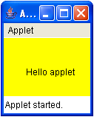

Where the applets are executed?

‘public static void main()’ method is not available incase of applets. This means, we can compile the applet code but we can not run it using a JVM.

Once the applet is created, we compile and obtain its byte code. This byte code is embedded in HTML page and the page is sent to the client computer. The client machine contains a browser like Internet Explorer, Netscape Navigator or Mozilla Firefox where the HTML page is viewed by the user. The same browser will execute the applet of the HTML page. The browser contains a small virtual machine called ‘applet engine’ which understands and runs the applet code.

Applets are executed by a program called ‘applet engine’ which is similar to virtual machine that exists inside the webbrowser at client side.

Applets can show images and animation, play sounds, take user input and send it to the server etc.

What is an Applet Life Cycle?

An applet is born with ‘init()’ method and starts functioning with ‘start()’ method. To stop the applet, the ‘stop()’ method is called and to terminate the applet completely from memory, the ‘destroy()’ method is called. Once the applet is terminated, we should reload the HTML page again to get the applet start once again from init() method. This cyclic way of executing the methods is called ‘Applet life cycle’.
Example:

import java.applet.Applet;
import java.awt.Graphics;

public class AppletLifeCycle extends Applet
{
String st = "Hello!";

public void init()
{
st = st + "<init()>";

}
public void start()
{
st = st + "<start()>";

}
public void stop()
{
st = st + "<stop()>";

}

public void destroy()
{
st = st + "<destroy()>";

}

public void paint( Graphics g )
{
st = st + "<paint()>";

g.drawString(st,30,50);

}
}

Compile the applet class

Javac AppletLifeCycle.java
MyApplet.html

<html>

<body>

<applet code="AppletLifeCycle.class" height=80 width=400>
</applet>
</body>
</html>
Execute the Applet program

Appletviewer MyApplet.html;

What is Hot Java?

HotJava is the first applet-enabled browser developed in Java to support running of applets. In 1995, when JavaSoft people demonstrated some animation using an applet on HotJava browser, developers started believing that it is possible to perform animation in the browsers.

How to pass the parameters to Applet?

We can supply user-defined parameters to an applet using <PARAM> tag. Each <param> tag has a name attribute that represents parameter name and contain value attributes represents the value of parameter.

Example:

import java.applet.Applet;
import java.awt.Graphics;

public class MyApplet extends Applet
{
String uname;
String pwd;

public void init()
{
uname = getParameter("username");
pwd = getParameter("password");

}

public void paint( Graphics g )
{
g.drawString("Username is "+uname,20,20);
g.drawString("Password is "+pwd,20,60);

}

}

Compile the applet class

Javac MyApplet.java

MyApplet.html

<html>

<body>
<applet code="MyApplet.class" height=80 width=400>

<param name="username" value="govind">
<param name="password" value="ggr">

</applet>

</body>

</html>

Execute the Applet program

Appletviewer MyApplet.html;

create the applet for graphics?

Example to graphics in Applets

import java.applet.Applet;
import java.awt.*;

public class MyApplet extends Applet
{
public void init()
{
setBackground(Color.yellow);
}

public void paint( Graphics g )
{
Font f = new Font( "TimesNewRoman",Font.BOLD,20);

g.setFont(f);
g.setColor(Color.red);

g.drawString("Keep smiling!!!",50,30);

g.drawOval(60,60,200,200);
g.fillOval(190,120,50,20);
g.fillOval(100,120,50,20);
g.drawLine(165,125,165,175);
g.drawArc(110,130,95,95,0,-180);

}
}

compile the applet class

Javac MyApplet.java

MyApplet.html

<html>

<body>

<applet code="MyApplet.class" height=300 width=300>
</applet>

</body>

</html>

Execute the Applet program

Appletviewer MyApplet.html

APPLET FOR Load and display the Image

import java.applet.Applet;
import java.awt.*;

public class MyApplet extends Applet
{

Image img;

public void init()
{
img =getImage(getCodeBase(),"globebank.gif");
}

public void paint( Graphics g )
{

for( int x=0; x<800; x++)
{

g.drawImage(img,x,0,null);

try{Thread.sleep(20);}
catch(InterruptedException e){}

}

}
}

compile the applet class

Javac MyApplet.java
MyApplet.html

<html>

<body>

<applet code="MyApplet.class" height=600 width=800>
</applet>

</body>
</html>

Execute the Applet program

Appletviewer MyApplet.html

APPLET FOR GETTING INPUT FROM THE USER

import java.applet.Applet;
import java.awt.*;

public class MyApplet extends Applet {

TextField t1, t2;

public void init() {

t1 = new TextField(8);
t2 = new TextField(8);

add(t1);
add(t2);

t1.setText(“0”);
t2.setText(“0”);
}

public void paint( Graphics g ) {

int a, b, c;
String st;

a=Integer.parseInt(t1.getText());
b=Integer.parseInt(t2.getText());

c = a + b;

st = String.valueOf(c);

g.drawString(“sum is : “,10,75);
g.drawString(st,100,75);

}

public void action(Event event, Object obj)
{
repaint();
return true;
}
}

compile the applet class

Javac MyApplet.java

MyApplet.html

<html>
<body>

<applet code="MyApplet.class" height=600 width=800>
</applet>

</body>
</html>

Execute the Applet program

Appletviewer MyApplet.html

( U N I T – V )

DATA STRUCTURES

93) What is Datastructure and Explain types of Data structures?

A data structure is an organized collection of data along with the allowed operations on that.

Classifications of Datastructures can be done in many ways. We may classfy the datastructures are

1)Linear Data Structures: In a Linear Data Structure the data items are arranged in a linear sequence.

Ex: Arrays, Stacks, Queues etc..

2)Non-Linear Data Structures: In a Non-Linear Data Structure the data items are not arranged in a linear sequence.

Ex: Trees, Graphs etc..

We may also classify the data structures as

1)Homogeneous Data Structures: In which all the elements are of same type.

2)Hetrogeneous Data Structures: In these kind of structures the elements may or may not be of same type

Ex: Records.

Another ways of classifying datastructures as

1)Static Data Structures: Here the sizes and structures associated memory is fixed at compile time.

2)Dynamic Data Structures: These are the ones, which expand or shrink as required during the program execution and their associated memory locations change.

Types of Datastructures

Sorting techniques, Stacks, Queues, Linked List, Trees, Graphs

Explain Bubble Sort with example

Sorting is nothing but arranging the elements in some logical order.

Bubble Sort:

- This is the simple sorting technique when compare with all other sorting

- In this sorting technique the adjacent elements are compared and interchanged if necessary

- Now consider an array A of n elements to be sorted
Process:

- compare the first two elements in the array, say A[0] and A[1]. If A[1] is less than A[0], then interchange the values.

- In the same way Compare A[1] and A[2], A[2] and A[3] until the last two elements are compared and interchange

- Repeat the above steps for n-1 passes

- After the completion of first pass the largest element is placed in nth position.

- After the completion of second pass the second element is placed in n-1 the position

- In the ith pass largest element is places in n-(i-1)th position.

- If the elements are not in sorted order it requires n-1 passes

- If the elements are in sorted order then it requires only one pass

Example:

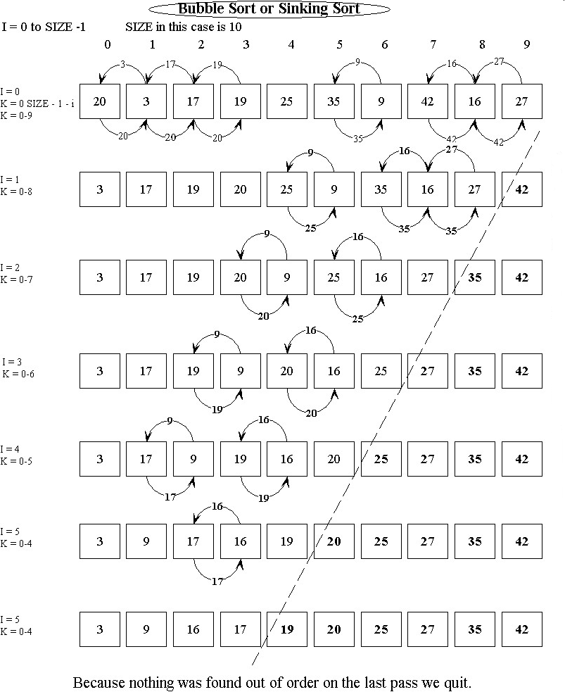

Program:

import java.util.*;

class BubbleSort
{

int size;
int []a;

Scanner sc = new Scanner(System.in);

void read() {
System.out.println("Enter the array size :: ");
size = sc.nextInt();

a = new int[size];

System.out.println("Enter the array elements :: ");
for( int i = 0; i < size; i++ )
{
System.out.print("Enter a["+i+"] value : ");
a[i] = sc.nextInt();
}
}

void display()
{
System.out.println(“The sorted array is:”);
for( int i=0; i<size; i++ )
System.out.print(a[i]+" ");
}

void sort()
{
for(int i = 0; i < size; i++ )
{
for(int j=0; j<(size-i-1); j++ )
{
if( a[j] > a[j+1] )
{
int temp = a[j];
a[j] = a[j+1];
a[j+1] = temp;
}
}
}
}
}

class ExOnBubbleSort
{
public static void main(String []args)
{
BubbleSort bs = new BubbleSort();

bs.read();
bs.display();
bs.sort();
bs.display();
}
}

Explain Selection Sort with example

Selection Sort:

- This is also one of the simplest sorting technique

Process:

- In the first step, first smallest element is searched in the list. Once the smallest element is found it is exchanged with the element, which is placed at first position. This completes the first pass.

- In the next step it searches for the second smallest element in the list and it is interchanged with element placed at second position. This is done in second pass

- This process is repeated until all the elements are sorted

- In the first pass first smallest element is placed in first position. In the second pass second smallest element is placed in second position and in the ith pass ith smallest element is placed in ith position. In the ith pass it requires n-i comparisions.

- It requires n-1 passes to complete the sorting

Example:

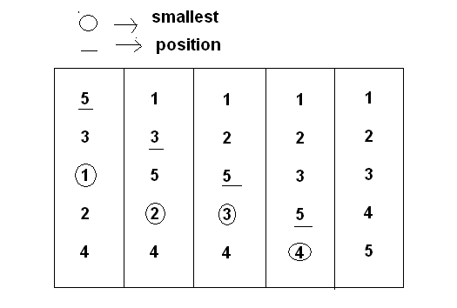

Program:

import java.util.*;

class SelectionSort
{
int size;
int []a;

Scanner sc = new Scanner(System.in);

void read()
{
System.out.println("Enter the array size :: ");
size = sc.nextInt();

a = new int[size];

System.out.println("Enter the array elements :: ");
for( int i = 0; i < size; i++ )
{
System.out.print("Enter a["+i+"] value : ");
a[i] = sc.nextInt();
}
}

void display()
{
for( int i=0; i<size; i++ )
System.out.print(a[i]+" ");
}

void sort()
{
int small, pos;

for( int i = 0; i < size; i++ )
{
small = a[i];
pos = i;

for(int j=i+1; j<=size-1; j++ )
{
if( small > a[j] )
{
small = a[j];
pos = j;
}
}

int temp = a[i];
a[i] = a[pos];
a[pos] = temp;
}
}
class ExOnSelectionSort
{
public static void main(String []args)
{
SelectionSort bs = new SelectionSort();

bs.read();
bs.display();
bs.sort();
bs.display();
}
}

Explain Insertion Sort with example

Insertion Sort:

- This is also one of the simplest sorting technique

Process:

- In the first pass, i is placed on second position. The values will be sorted from i^{th} position to upto starting value.

- In the next pass I is placed on third position. The values will be sorted from i^{th} position to upto starting value

- This process is repeated until i reached on last position

- In the last pass all elements will be arranged in ascending order

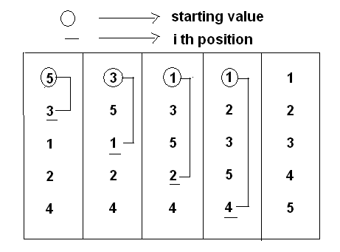
Program:

import java.util.*;

class InsertionSort
{
int size;
int []a;

Scanner sc = new Scanner(System.in);

void read()
{
System.out.println("Enter the array size :: ");
size = sc.nextInt();

a = new int[size];

System.out.println("Enter the array elements :: ");
for( int i = 0; i < size; i++ )
{
System.out.print("Enter a["+i+"] value : ");
a[i] = sc.nextInt();
}
}
void display()
{
for( int i=0; i<size; i++ )
System.out.print(a[i]+" ");

System.out.println();
}

void sort()
{

for( int i = 0; i < size; i++ )
{
for(int j=i; j>0; j-- )
{
if( a[j] < a[j-1] )
{
int temp = a[j];
a[j] = a[j-1];
a[j-1] = temp;
}
}
}

}
}

class ExOnInsertionSort
{
public static void main(String []args)
{
InsertionSort is = new InsertionSort();

is.read();
is.display();
is.sort();
is.display();
}

}

Explain Quick Sort with example

Quick Sort: This sorting is very efficient when given set is large

Process:

- In this method, first the list is divided into two, such a way that the left side elements are must less then the key value and right side elements are must greater than key value

- It takes one of the element as key element. By default or usually the first element is treated as the key element

- After he first pass key element is placed in its correct position

- Scan from left till we encounter the element which is greater than the key value. Scan from right to encounter the element which is less than the key value. Now interchange these two values.

- And again continue this process. When these two searchings ae crossover then interchange the least element with the key value. This is repeated until all the elements are sorted

Example:

Before Sorting:

18, 7, 16, 4, 2, 3, 24, 31, 91

After Sorting:

2, 3, 4, 7, 16, 18, 24, 31, 91

Step-1:

In the step-1 take most left position value as ‘key’. That is 18. ‘Low’ is placed at next position of the key and ‘high’ will be placed at lost position of the array.

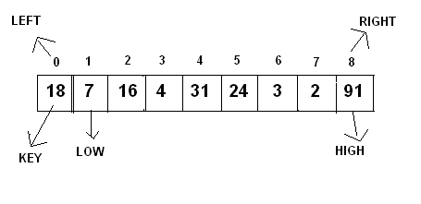
Step-2:

In the step-2 First we check if low value is less then key than increment the low position otherwise stop that process.
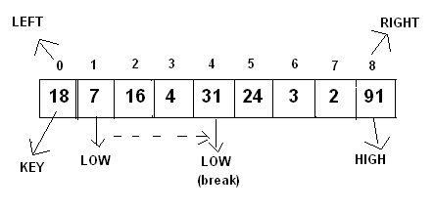

Step-3:

In the step-3 And check high position value is greater than key value. If high position value is greater than key value decrement the high position otherwise stop that process.
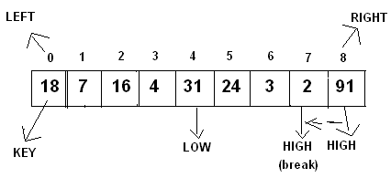
Step-4:

When both low and high process are stopped interchange the low and high position value and continue the process until they are over cross.

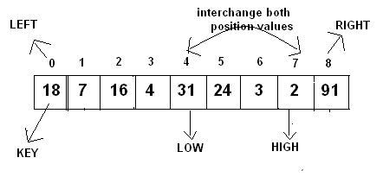
Step-5:

After inter changing the values the array will be shown as below

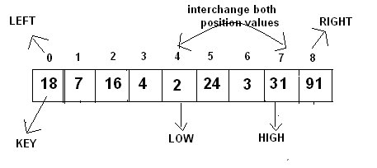
Step-6:

After interchanging low and high position values again check the low position value is less than key value and check high position value is greater than key value. If both high and low positions are over crossed than interchange the key and high position value

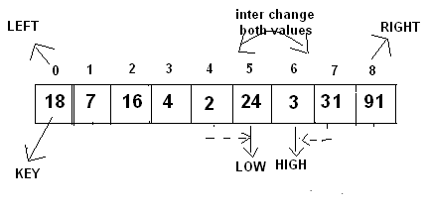

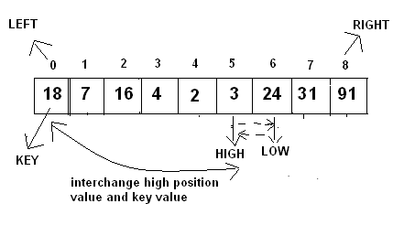

Step-7:

After interchanging high position value and key value sort the array from left position to high and sort the values from low to right. This process will continued when left is greater than right. When left is greater than right than all array values are arranged in ascending order.

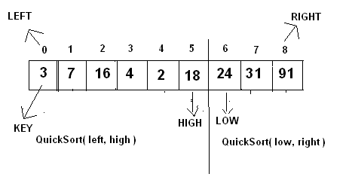

Program:

import java.util.Scanner;

class MyClass
{
int key, low, high;

void quick_sort(int []a, int left, int right )
{
if(left>=right) return;

key = a[left];
low = left + 1;
high = right;

while(low<=high)
{
while( low<=high && a[low]<key )
{
low++;
}

while(high>=low && a[high]>key)
{
high--;
}

if(low <= high)
{
int temp = a[low];
a[low] = a[high];
a[high] = temp;
}

}//while end

a[left] = a[high];
a[high] = key;

quick_sort(a,left,high-1);
quick_sort(a,low,right);

}//function

};

class ExOnQuickSort
{
public static void main(String[] args)
{

int size;
int []a;

Scanner sc = new Scanner(System.in);

System.out.print("Enter array size : ");
size = sc.nextInt();

a = new int[size];

System.out.print("Enter "+size+" values :");
for(int i=0; i<size; i++)
{
a[i] = sc.nextInt();
}

System.out.println("------------");
System.out.println("Array is : ");
System.out.println("------------");

for( int i=0; i<size; i++)
{
System.out.print(a[i]+" ");
}
System.out.println();

MyClass mc = new MyClass();
mc.quick_sort( a, 0, size-1 );

System.out.println("------------");
System.out.println("Array is : ");
System.out.println("------------");
for( int i=0; i<size; i++)
{
System.out.print(a[i]+" ");
}
}
}

Explain the implementation of stack

Stack is a linear data structure to which insertions and deletions are done from one end called top. It follows Last In First Out(LIFO) technique. The technique operation for inserting an element into the stack is referred as push, and for deleting an element is referred as POP.

Inserting an element into the stack when it is full leads to stack overflow. Deleting an element from stack when it is empty leads to stack underflow.

Applications of stacks:

- Parenthesis matching
- Evaluation of postfix expressions
- Infix to prefix conversions
- Infix to postfix conversions
- Recursion

Consider the stack with size is 5

1)Empty stack

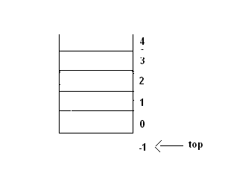
- push ‘10’ value into stack
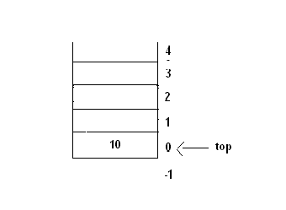

- Push ‘20’ value into stack
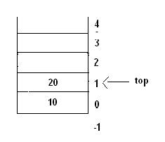

- Push ‘30’,’40’ and ‘50’ value into stack

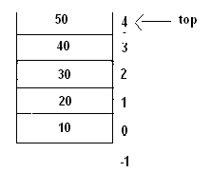

5) when we push another element stack is full because the top reached maximum position. When we remove the elements at stack top position will be moved down upto -1. When top reaches -1 than stack is empty.

6)when we call pop method the top position item will be removed and top will be decremented to 1.

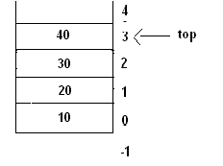

7) Pop40 from the stack

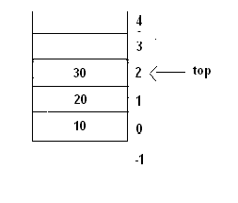
Program:

class Stack
{

final int size = 5;

int []stack = new int[size];

int top=-1;

void push( int ele )
{
if( top == size-1 )
System.out.println("stack overflow");
else
{
top++;
stack[top] = ele;
}

}

void pop()
{
if( top == -1 )
System.out.println("Stack is empty");
else
{
int ele = stack[top];

top--;

System.out.println("popped element is : "+ele);
}
}

void display()
{
System.out.println("Stack is : ");

for( int i=top; i>=0; i-- )
{
System.out.println(stack[i]);
}

}

};

class ExOnStack
{
public static void main(String[] args)
{
Stack s = new Stack();

s.push(10);
s.push(20);
s.push(30);
s.push(40);

s.display();

s.pop();
s.display();

}
}

99) Explain the implementation of Queue

Queue is a linear data structure to which insertions and deletions are done from two ends called front and rear. Insertions are done from one end called rear and deletions are done from other end is called front. It follows First In First Out(FIFO) technique.

The technical name from inserting an element into the queue is called ‘Enqueue’ and deleting an element from the queue is called ‘Dequeue’.

Queue is used in time sharing systems where many user jobs will be waiting in the system queue for processing. These jobs may request the services of CPU, main memory or external devices such as printer.

Consider the Queue with size is 5

Step-1:
-1 0 1 2 3 4
Front Rear

Insert the 10 element in Queue

10
Step-2:
-1 0 1 2 3 4
Front Rear

Insert the 20 element in Queue

10 20
Step-3:
-1 0 1 2 3 4
Front Rear
Insert the 30, 40 and 50elements in Queue

10 20 30 40 50
Step- 4:
-1 0 1 2 3 4
Front Rear

If we try to insert another element in queue. It displays queue is full message.

Removing values from the queue

Removing 10 from Queue
20 30 40 50

Step- 5:
-1 0 1 2 3 4
Front Rear
Removing 20 from Queue
30 40 50

Step- 6:
-1 0 1 2 3 4
Front Rear

Removing 30,40 from Queue
50

Step- 7:
-1 0 1 2 3 4
Front Rear

In the next step when we remove the 50 the front, rear will becomes to -1 position and que becomes to empty.

Program:

class Queue
{

final int size = 5;

int []que = new int[size];

int front = -1;
int rear = -1;

void enque( int ele )
{
if( rear == size-1 )
System.out.println("Queue is full");
else
{
rear = rear + 1;
que[rear] = ele;

if( front == -1 )
front = 0;
}

}

void deque()
{
if( front == -1 )
System.out.println("Queue is empty");

else
{
int ele = que[front];

if( front == rear )
front = rear = -1;
else
front++;

System.out.println("deleted element is : "+ele);

}
}

void display()
{
System.out.println("Queue is : ");

for( int i=front; i<=rear; i++ )
{
System.out.println(que[i]);
}

}

};

class ExOnQueue
{
public static void main(String[] args)
{

Queue q = new Queue();

q.enque(10);
q.enque(20);
q.enque(30);
q.enque(40);
q.enque(50);

q.display();

q.deque();
q.display();

}
}

Explain the implementation of Circular Queue

In linear Queues once the element is deleted from queue, that location cannot be filled. So the drawback of linear queue is wastage of memory. This problem can be solved by circular queue.

Circular queue is a linear list in which once the rear pointer reaches max_size then it is placed at 0th position. i.e. making the queue is a circular. Similarly, when the front pointer reaches max_size then it is reset to 0.

Consider the Circular Queue with size is 5
Step-1:
-1 0 1 2 3 4
Front Rear

Insert the 10 element in Queue

10
Step- 2:
-1 0 1 2 3 4
Front Rear
Insert the 20 element in Queue

10 20
Step- 3:
-1 0 1 2 3 4
Front Rear
Insert the 30, 40 and 50elements in Queue

10 20 30 40 50
Step- 4:
-1 0 1 2 3 4
Front Rear
If we try to insert another element in queue. It displays queue is full message.
Removing 10 from Queue
20 30 40 50

Step- 5:
-1 0 1 2 3 4
Front Rear
Removing 20 from Queue
30 40 50

Step- 6:
-1 0 1 2 3 4
Front Rear
Insert 60 value in queue

60 30 40 50

Step- 7:
-1 0 1 2 3 4
Rear Front
Insert 70 value in queue

60 70 30 40 50

Step- 8:
-1 0 1 2 3 4
Rear Front

When we insert another value the queue displays queue is full bcz rear and front is placed on same position. There is no space to insert the new element. So the queue is full. In the same way front also placed at first position once the last position is reached.

Program:

class CQue
{
final int size = 5;

int []cque = new int[size];

int front = -1;
int rear = -1;

void enque(int ele)
{
if( (front==0 && rear==size-1) ||
(front == rear + 1) )
System.out.println("Queue is full");
else
{
if(rear == size)
rear = 0;
else
rear++;

cque[rear] = ele;

if(front == -1)
front = 0;
}
}

void deque()
{
if(front == -1)
System.out.println("Queue is empty");
else
{
if(front == rear)
front = rear = -1;
else
{
if(front == size)
front = 0;
else
front++;
}
}

}

void display()
{

if(front == -1)
System.out.println("Queue empty");

if(front != -1)
{
if(front <= rear)
{
for(int i = front; i <= rear; i++)
System.out.println(cque[i]);
}
else
{
for ( int i = front; i <= size; i++ )
System.out.println(cque[i]);

for ( int i = 0; i <= rear; i++ )
System.out.println(cque[i]);
}

}

};

class ExOnCQueue
{
public static void main(String[] args)
{

CQue cq = new CQue();

cq.enque(10);
cq.enque(20);
cq.enque(30);
cq.enque(40);
cq.enque(50);

cq.display();

cq.deque();
cq.display();

}
}

Explain the implementation of DeQue

Deque:

- A double ended queue is a linear list in which insertions are done from both the ends but not in the middle

- In linear queue, elements are inserted from rear and deleted from front. But in deque elements can be inserted from front and elements can be deleted from rear.

-1 0 1 2 3 4
Front Front Rear Rear
(delete) (insert) (insert) (delete)

Program:

class Deque
{
final int size = 5;

int []queue = new int[size];

int front = -1;
int rear = -1;

void InsertFront( int ele )
{

if( front == 0 )
System.out.println("cant insert an element");

else
{
if( front == -1 )
front = 0;
else
front = front-1;

queue[front] = ele;
}
}

void InsertRear( int ele )
{
if( rear == size-1 )
System.out.println("Queue is overflow");
else
{
rear = rear + 1;
queue[rear] = ele;

if( front == -1 )
front = 0;
}
}

void DeleteFront()
{
if( front == -1 )
System.out.println("Queue is empty");
else
{
System.out.println("deleted element is :: ");
System.out.print(queue[front]);

if( front == rear )
front = rear = -1;
else
front = front + 1;

}
}

void DeleteRear()
{
if( rear == -1 )
System.out.println("Queue is empty");
else
{
if( front == rear )
front = rear = -1;
else
rear = rear - 1;
}

}

void Display()
{
System.out.println("Queue elements are : ");
for(int i=front; i<=rear; i++)
System.out.println(queue[i]);

}

};

class ExOnDeQue
{
public static void main(String[] args)
{

Deque d = new Deque();

d.InsertRear(10);
d.InsertRear(20);
d.InsertRear(30);
d.DeleteFront();
d.InsertFront(40);

d.Display();
}
}

Explain the implementation of Single Linked List

Linked List:

Linked List is one of the basic type of dynamic structure. A list grows when elements are added and it is reduced when elements are deleted. This can be achieved by dynamic memory management techniques. Dynamic memory management techniques permit us to allocate additional memory space or to release unwanted space at runtime. It provides flexibility in adding, deleting or rearranging data items at runtime. Dynamic memory management technique uses the memory management functions(new and delete), which are used for allocating and freeing memory during the program execution.

Structure of the List
ADDRESS

DATA
Pointer to Next Node
N O D E

A List refers to set of items organized sequentially. A list can also be represented by making each item in the list part of a structure that also contains a pointer ‘Next’ which holds the next item address.

Each structure of the list is called a node and each node consists two fields

- First field contains information of data item

- Second field contains the address of next node or next element

The next address, which is used to access the next node is known as a pointer. The entire linked list can be referred and accessed by a head pointer which points to the first node of the list. It is a list identifier, which contains the address of the first element of the list.
Advantages:

- Insertion and deletion is efficient
- Efficient memory management

The following is the representation of singly Linked List

20 300
40NULL
30 400 0 400

10 200
100 200 300 400

Insert at Begin:
20 300
40 NULL
30 400 0 400

10 200
HEAD
50 100
500 200 300 400
100 200 300 400

Insert at Middle:
HEAD
20 500
40 NULL
30 400 0 400

10 200
50 400
500 200 300 400
100 200 300 400
Insert at End:
20 300
40 500
30 400 0 400

10 200
500 200 300 400
100 200 300 400
50 NULL
HEAD
Delete at Begin:
20 300
40 NULL
30 400 0 400

10 200

100 200 300 400
HEAD

Delete at Middle:
20 400
40 NULL
30 400 0 400

10 200
100 200 300 400
HEAD

Delete at End:
20 300
40 500
30 NULL 0 400

10 200
100 200 300 400
HEAD

Program:

import java.util.Scanner;

class Node
{
int data;
Node next;
}

class LinkedList
{

private Node head = null;

// Read each value and add it to the list

public void create()
{
Node temp=null,prev=null;

int value;
String choice;

Scanner scan = new Scanner(System.in);

head = null;

do
{
System.out.println("Enter a value");
value = scan.nextInt();

temp = new Node();
temp.data = value;

if( head == null )
head = temp;
else
prev.next = temp;

prev = temp;

// to read enter key
scan.nextLine();

System.out.println("continue y/n");
choice = scan.nextLine();
}
while( ! choice.equalsIgnoreCase("n") );

temp.next = null;
}

public void display()
{
if( head == null )
{
System.out.println("list empty");
return;
}

System.out.println("values in the list ");
for( Node t = head ; t != null; t = t.next )
System.out.print(" " + t.data );
}

void insertAfter(int key, int value)
{
Node t,n;

t = head;

while ( t != null )
{
if( t.data == key )
{
n = new Node();
n.data = value;
n.next = t.next;
t.next = n;
System.out.println("inserted");
return;
}

t = t.next;
}

System.out.println("not inserted");
}

void insertBefore( int key , int value )
{
Node t,p,n;

p = null;

t = head;

while( t != null )
{
if( t.data == key ) // found
{
n = new Node();
n.data = value;

n.next = t;

if( t == head ) // case 1
head = n;
else // case 2
p.next = n;

System.out.println("inserted");
return;
}

p = t;
t = t.next;
}

System.out.println("not inserted");
}

void delete( int key )
{
Node t,p;

p = null;

t = head;

while( t != null )
{
if( t.data == key ) // found
{
if( head == t ) // case 1
head = head.next;
else // case 2
p.next = t.next;

System.out.println("deleted");
return;
}

p = t;
t = t.next;
}

System.out.println("not deleted");
}

}

class LinkedListEx
{
static int menu()
{
int choice;
Scanner scan = new Scanner( System.in );
System.out.println("\n"); // two lines
System.out.println("1:create");
System.out.println("2:insert after");
System.out.println("3:insert before");
System.out.println("4:delete");
System.out.println("5:display");
System.out.println("6:exit");

System.out.print("Enter your choice : ");
choice = scan.nextInt();

return choice;

}

public static void main(String[] args)
{

LinkedList list = new LinkedList();

int key,value,choice;

while( true )
{

choice = menu();

switch( choice )
{

case 1:
list.create();
break;

case 2:
Scanner scan = new Scanner(System.in);

System.out.println("enter key");
key = scan.nextInt();

System.out.println("enter value");
value = scan.nextInt();

list.insertAfter(key,value);
break;

case 3:
Scanner scan1 = new Scanner(System.in);

System.out.println("enter key");
key = scan1.nextInt();

System.out.println("enter value");
value = scan1.nextInt();

list.insertBefore(key,value);
break;

case 4:
Scanner scan2 = new Scanner(System.in);

System.out.println("enter key to delete");
key = scan2.nextInt();

list.delete( key );
break;

case 5:
list.display();
break;

case 6:
return;

}
}
}
}

Explain the implementation of Double Linked List

Double Linked List:

- The drawback of singly linked list is we cannot traverse the list backwards

- To Traverse the list in reverse direction and forward direction the node should have two pointers

- So we define a structure for a node, which contains three fields, in which one field is data field and other two are address fields. One is left address and another one is right address.

- A list contains this type of nodes is known as doubly linked list or two-way list

Structure of the Double Linked List

DATA
Pointer to Next Node
N O D E
Pointer to Prev Node
ADDRESS

The following is the representation of double Linked List
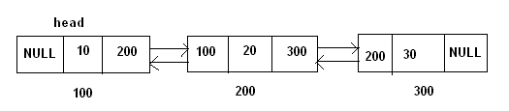

Insert at Begin:

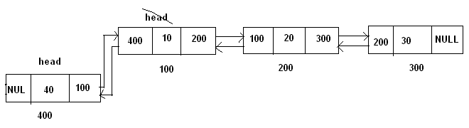

Insert at Middle:
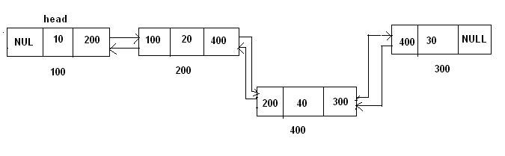
Insert at End:
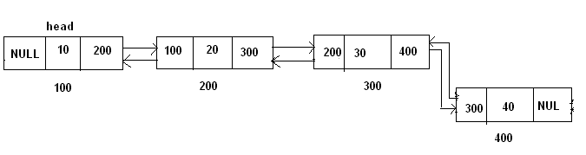
Delete at Begin:

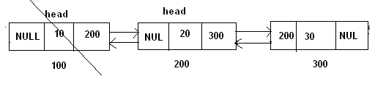

Delete at Middle:
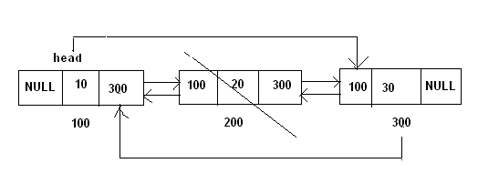
Delete at End:

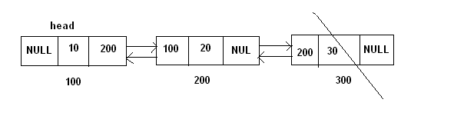

Program:

import java.util.Scanner;

class Node
{
Node prev;
int data;
Node next;
}

class DoubleLinkedList
{
private Node head=null;

// Read each value and add it to the list

public void create()
{
Node p = null, temp = null;

int value;
String choice;

Scanner scan = new Scanner(System.in);

head = null;

do
{
System.out.println("Enter a value");
value = scan.nextInt();

temp = new Node();
temp.data = value;

if( head == null )
head = temp;
else
{
p.next = temp;
temp.prev = p;
}

p = temp;

// to read enter key
scan.nextLine();

System.out.println("continue y/n");
choice = scan.nextLine();

}while( ! choice.equalsIgnoreCase("n") );

head.prev = null;
temp.next = null;
}

public void display()
{
if( head == null )
{
System.out.println("list empty");
return;
}

System.out.println("values in the list ");
for( Node t=head; t!=null; t=t.next )
System.out.print(" "+t.data );
}

public void insertAfter(int key, int value)
{
Node t,n;

t = head;

while ( t != null )
{
if( t.data == key )
{
n = new Node();
n.data = value;

n.prev = t;

n.next = t.next;

if( t.next != null )
t.next.prev = n;

t.next = n;

System.out.println("inserted");
return;
}
t = t.next;
}
System.out.println("not inserted");
}

public void insertBefore( int key , int value )
{
Node t,n;

t = head;

while( t != null )
{
if( t.data == key ) // found
{
n = new Node();
n.data = value;

if( t == head ) // case 1
{
n.prev = null;
n.next = t;
t.prev = n;
head = n;
}
else // case 2
{

n.prev = t.prev;
n.next = t;
t.prev.next = n;
t.prev = n;
}

System.out.println("inserted");
return;

}

t = t.next;
}

System.out.println("not inserted");
}

public void delete( int key )
{
Node t;

t = head;

while( t != null )
{
if( t.data == key ) // found
{

if( t == head ) // case 1
{
head = head.next;

if( head != null )
head.prev = null;
}
else // case 2
{
t.prev.next = t.next;

if( t.next != null )
t.next.prev = t.prev;
}

System.out.println("deleted");
return;
}

t = t.next;
}
System.out.println("not deleted");
}

} // end of DoubleLinkedList class

class DoubleLinkedListEx
{
static int menu()
{
int choice;
Scanner scan = new Scanner( System.in );
System.out.println("\n"); // two lines
System.out.println("1:create");
System.out.println("2:insert after");
System.out.println("3:insert before");
System.out.println("4:delete");
System.out.println("5:display");
System.out.println("6:exit");
System.out.print("Enter your choice : ");
choice = scan.nextInt();
return choice;
}

public static void main(String[] args)
{
DoubleLinkedList list = new DoubleLinkedList();

int key,value,choice;

while( true )
{
choice = menu();

switch( choice )
{

case 1:
list.create();
break;

case 2:
Scanner scan = new Scanner(System.in);

System.out.println("enter key");
key = scan.nextInt();

System.out.println("enter value");
value = scan.nextInt();

list.insertAfter( key , value );
break;

case 3:
Scanner scan1 = new Scanner(System.in);

System.out.println("enter key");
key = scan1.nextInt();

System.out.println("enter value");
value = scan1.nextInt();

list.insertBefore(key,value);
break;

case 4:
Scanner scan2 = new Scanner(System.in);

System.out.println("enter key to delete");
key = scan2.nextInt();

list.delete(key);
break;

case 5:
list.display();
break;

case 6:
return;

}
}
}
}

Explain the implementation of Binary Search Trees
Trees:

A tree is a nonlinear data structure mainly used to represent the hierarchical relationship between data. Trees are used in compiler construction, database design, windows, operating systems program etc..

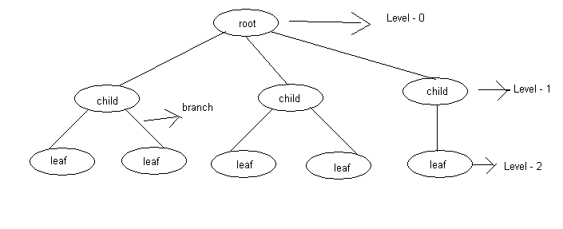
- The first node is called root node.

- The nodes, which are directly connected to root, are called child nodes

- A link between a parent and its child is called a branch

- A node with no children called a leaf node or terminal node

- The children of the same parent are called siblings

- The level of root node can be 0 or 1. All other nodes in the tree is having level one more than level of its root. The level of the above tree is 2

- The degree of a tree is the maximum degree of the node in the tree. The degree of the above tree is 3

- Height or depth of a tree is to be the maximum level of any node in the tree.

Binary Tree:

Root have children either 0 or 1 or 2 is called binary tree. Every node have 0 or 1 or 2 childrens.

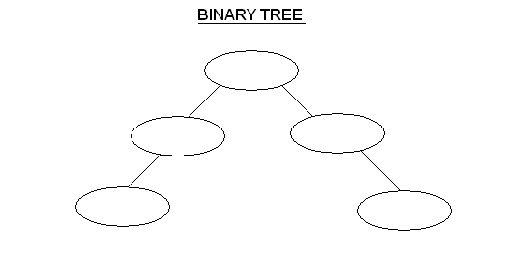

Complete Binary Tree:

Root have children either 0 or 2 is called Complete binary tree. Every node have 0 or 1 or 2 childrens.

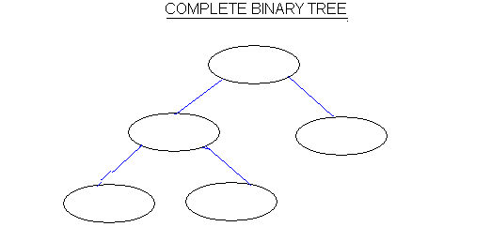

Binary Search Tree:

In Binary Search tree left child values must be less than root value and right children values must be greater than root value.

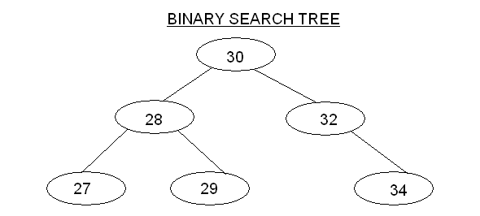

Construct the binary search tree for the given elements

19 8 16 4 32 64 45 91

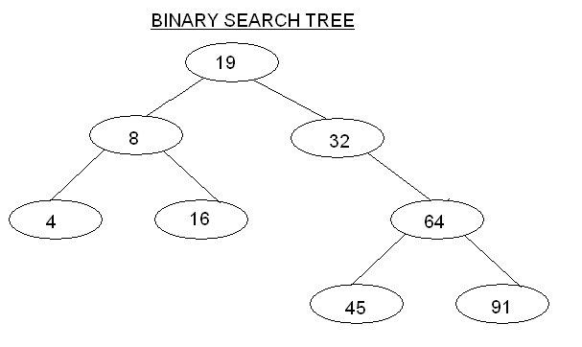
Traversals of Tree:

1)Inorder :Left, Root, Right

2)PreOrder: Root, Left, Right

3)PostOrder: Left, Right, Root

InOrder: 4, 8, 16, 19, 32, 45, 64, 91

Pre Order: 19, 8, 4, 16, 32, 64, 45, 91

Post Order:4, 16, 8, 45, 91, 64, 32, 19

Source_code:

import java.util.Scanner;

class Node
{
Node left;
int data;
Node right;
}
class BinarySearchTree
{

private Node head;

private Node Insert( Node T, int value )
{

if( T == NULL )
{
T = new Node();
T.data = value;
}
else if( value < T.data )

T.left = Insert(T.left,value);

else if( value > T.data )
T.right = Insert(T.right,value);

return T;

}

public void InsertNode( int value )
{
head = Insert(head,value);
}

private void Inorder( Node t )
{

if( t != NULL )
{
Inorder(t.left);
System.out.println(" "+t.data);
Inorder(t.right);
}

}
private void Preorder( Node t )
{

if( t != NULL )
{
System.out.println(" "+t.data);

Preorder(t.left);
Preorder(t.right);
}

}

private void Postorder( Node t )
{

if( t != NULL )
{
Postorder(t.left);
Postorder(t.right);
System.out.println(" "+t.data);
}

}

public void PrintInorder()
{
Inorder(head);
}

public void PrintPreorder()
{
Preorder(head);
}

public void PrintPostorder()
{
Postorder(head);
}

private Node Delete( Node t, int key )
{

if( t == NULL )
return NULL;

if( key < T.data )
T.left = Delete(T.left,key);
else
if( key > T.data )
T.right = Delete(T.right,key);

else //if data found
{

if( T.left==NULL && T.right==NULL )
return NULL;

if( T.left == NULL )
return T.right;

if( T.right == NULL )
return T.left;

//both childs are exist

Node min = findmin(T.right);

T.data = min.data;

T.right = Delete(T.right,min.data);
}

return T;
}

private Node findmin( Node T )
{

if( T == NULL )
return NULL;

while( T.left != NULL )
T = T.left;

return t;

}
public void DeleteNode( int key )
{

head = Delete(head,key);

}

}//class close

class TreeEx
{
static int menu()
{
int choice;
Scanner scan = new Scanner( System.in );
System.out.println("\n"); // two lines
System.out.println("1:Insert");
System.out.println("2:Inorder");
System.out.println("3:Preorder");
System.out.println("4:Postorder");
System.out.println("5:Delete");
System.out.println("6:exit");
System.out.print("Enter your choice : ");
choice = scan.nextInt();
return choice;
}

public static void main(String[] args)
{

BinarySearchTree bt = new BinarySearchTree();

int key,value,choice;

Scanner sc = new Scanner(System.in);

while( true )
{
choice = menu();

switch( choice )
{
case 1:
System.out.println("enter value");
value = scan.nextInt();

bt.InsertNode(value);
break;

case 2:
bt.PrintInorder();
break;

case 3:
bt.PrintPreorder();
break;

case 4:
bt.PrintPostorder();
break;

case 5:
System.out.println(
"enter value to delete");
value = scan.nextInt();

bt.DeleteNode(value);
break;

case 6:
return;

}
}
}
}

What is a Graph? How graphs are represented
Graph:

A Graph G consists of a set V of Vertices(Nodes) and set of edges(arcs) E.

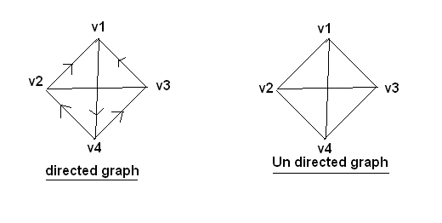

- Any two nodes, which are connected by an edge in a graph is called adjacent nodes.

- In a graph G=<V,E> an edge which is directed from one node to another is called directed edge while an edge has no specific direction is called as undirected edge.

- A graph in which every edge is directed as called as Directed Graph or a digraph.

- A graph in which every edge is undirected is called an undirected graph.

- A graph, if some edges are directed and some edges are undirected then it is called mixed graph

Representations of Graph:

Graph can be Represented in two ways

1)Adjacency matrices
2)Adjacency Lists

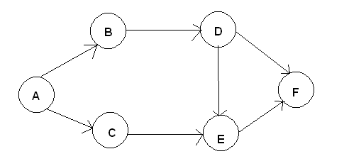

1) Adjacent Matrices Representation

 | A | B | C | D | E | F
A | 0 | 1 | 1 | 0 | 0 | 0
B | 0 | 0 | 0 | 1 | 0 | 0
C | 0 | 0 | 0 | 0 | 1 | 0
D | 0 | 0 | 0 | 0 | 1 | 1
E | 0 | 0 | 0 | 0 | 0 | 1
F | 0 | 0 | 0 | 0 | 0 | 0

2) Linked List Representation

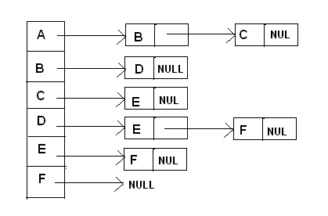

Explain about Minimum spanning Tree

Minimum Spanning Tree:

A minimum spanning tree is a spanning which contains minimum cost. A cost of a spanning tree is the sum of the costs(weights) of its edges.

The below given graph is a weighted graph. i.e. weights are assigned to the edges. Now we have to find the minimum spanning tree to the given graph.

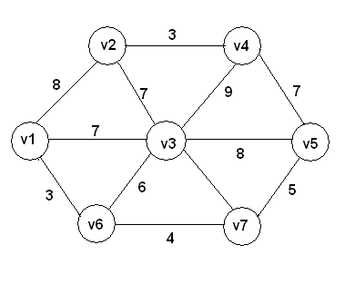

First Step:

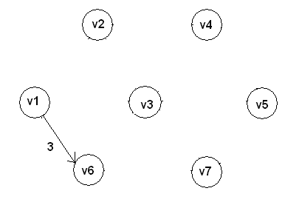
Second Step:

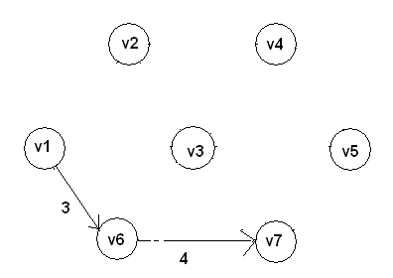

Third Step:

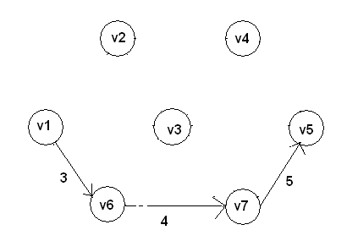

Fourth Step:

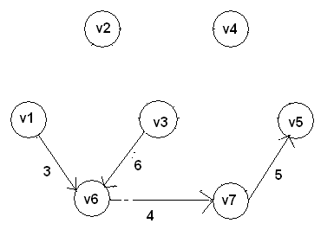
Fifth Step:

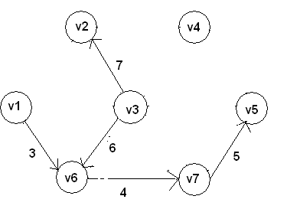

Sixth Step:
